Setting outcomes, and measuring and reporting performance of regional council pest and weed management programmes

Guidelines and resource materials

Setting outcomes, and measuring and reporting performance of regional council pest and weed management programmes

Guidelines and resource materials

Chris Jones, Phil Cowan
Landcare Research

Will Allen
Will Allen & Associates

Prepared for:

New Zealand regional councils

March 2012
Landcare Research, Gerald Street, PO Box 40, Lincoln 7640, New Zealand, Ph +64 3 321 9999, Fax +64 3 321 9998, www.landcareresearch.co.nz

Will Allen & Associates, PO Box 30108, Barrington, Christchurch 8244, New Zealand, Ph +64 3 980 4216
Landcare Research Contract Report: |  | LC144
Disclaimer
This report has been prepared by Landcare Research for regional councils. If used by other parties, no warranty or representation is given as to its accuracy and no liability is accepted for loss or damage arising directly or indirectly from reliance on the information in it.

© Landcare Research New Zealand Ltd 2012
This information may be copied and distributed to others without limitation, provided Landcare Research New Zealand Ltd and the source of the information are acknowledged. Under no circumstances may a charge be made for this information without the written permission of Landcare Research.

Contents
1 Introduction and background 1

1.1 Purpose 1

1.2 Changing focus to outcomes 1

1.3 Measuring performance 2
2 Logic models 5

2.1 Basic concepts 5

2.2 Logic models applied to pest management 6

2.3 Primary components 7

2.4 Supporting information for logic models 10

2.5 Common headaches for logic models: attribution and time-lag 13
3 Building logic models 15

3.1 Overview 15

3.2 Involving stakeholders 15

3.3 Scoping and planning 16

3.4 Developing outcomes 20

3.5 Outputs, activities and inputs 23

3.6 Assumptions and uncertainties 25

3.7 Internal and external influencing factors 26

3.8 Final checks 26

3.9 Practicalities 26
4 Assessing progress and performance 29

4.1 Performance measures and indicators 29

4.2 What are good measures and indicators of progress? 30

4.3 Choosing ‘the vital few’ measures and indicators 31

4.4 Proxy indicators 31

4.5 Protocols for indicator measurement 31

4.6 Reporting links 32
5 Evaluation and reporting 36

5.1 Overview 36

5.2 Evaluation 37

5.3 Reporting 38

5.4 Linking reports to the programme’s logic model 39

5.5 Using performance indicators in an evaluation, reporting and improvement plan 39
6 Examples 40
7 Acknowledgements 46
8 References (cited and additional) 46

Appendix 1 – Background to the Envirolink Tools project, and national and regional contexts for measuring pest management performance 49
Appendix 2 – Logic model for the Didymo Long-term Management Plan 52
Appendix 3 – Biodiversity indicators comprising the regional council terrestrial biodiversity monitoring framework 59

Introduction and background

Purpose
Regional councils in New Zealand spend over $41 million per year (2008 estimate) managing weed and animal pests. Councils have agreed they need to better demonstrate that this significant expenditure on pest management is achieving the Long Term Council Community Plan (LTCCP) outcomes and represents good value to the community. This need, in part, reflects a historical emphasis on recording and reporting what pest management was done (e.g. number of site visits; number of pests killed), not what difference it made. Councils have also been constrained until recently by limited understanding of and capability to undertake performance measurement. Appendix 1 describes the context and need for this work in more detail.
These guidelines and resource materials aim to help regional council biosecurity managers and staff better structure, measure and report on the performance of their pest management programmes. The principles and protocols described are applicable to pest management for a wide range of outcomes, including biodiversity conservation, community involvement in pest management, and management of agricultural pests, and to most other areas of council activity.
The guidelines cover:
Section 1 – Introduction & Background: an overview of performance measurement as a management tool.
Section 2 – Logic Models: the principles behind and structure of logic models, a commonly-used method of describing and evaluating the performance of a programme.
Section 3 – Developing Logic Models: how to develop a logic model for a programme, including the definition of outcomes.
Section 4 – Assessing Progress and Performance: how a set of performance indicators can be developed for a programme.
Section 5 – Evaluation & Reporting: how performance information can be linked to reporting requirements and used to improve a pest management programme.

Changing focus to outcomes
Making the change to an outcome focus requires a shift from setting ‘service delivery’-type performance targets and measuring and reporting on activities and outputs (such as site visits, the amount of spraying with herbicides or possum control done) to measuring and reporting on the difference made to, for example, native biodiversity or agricultural production as a result of pest management. Another way of thinking about this is in terms of the difference between pest management efficiency and effectiveness (Figure 1).
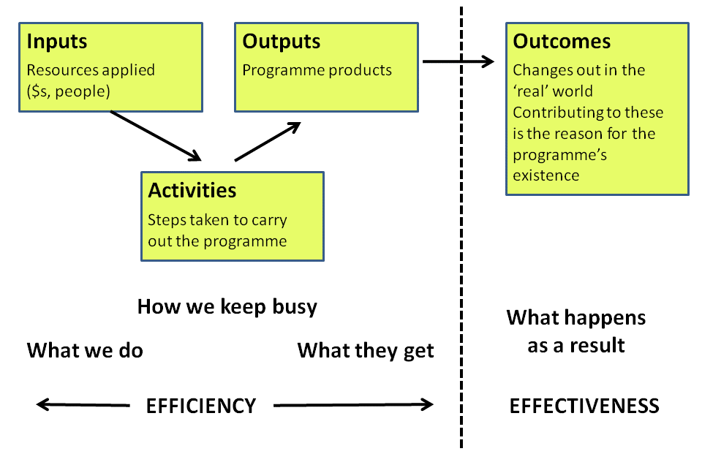
Figure 1 A simple logic model highlighting the difference between an output focus (how well or how cost-effectively things are done, e.g. number of possums killed) and an outcomes focus (the differences made by the programme, e.g. gains in biodiversity).
The key rationale for a shift from output to outcome measurement and reporting for DOC pest control activities was summarised effectively as:
This activity-based reporting pattern is consistent throughout the annual reports since 1998/99. The sections on animal pest control ... report achievement in terms of the area treated, under sustained management and total benefit area. There is no indication of what difference this pest control effort has made to predator or browser pressure on the native biota, or any indication of change in the condition of native biota. Furthermore, each animal pest is reported on separately so there is no way to identify if (or where) there may be synergistic benefits from multiple pest control in the same area. In short, there is no reporting against the fundamental purposes (e.g. defending and improving the condition of our natural heritage) for undertaking these activities. (Stephens et al. 2002).
The description applies equally well to other pest management agencies in New Zealand.

Measuring performance
There are two main reasons for measuring the performance of a programme: accountability and describing progress (see Box 1). Accountability to ratepayers and national or local politicians is particularly important for the public sector. In recent years there has been an increased emphasis on public accountability for the levels of service to stakeholders in return for the rates and taxes imposed by government. Performance measurement has shifted focus away from whether or not services and outputs are being delivered to the harder question about whether those outputs are actually contributing to high level system outcomes and whether the approach taken is the most efficient and effective way to achieve those outcomes (Schacter 2002).
Box 1 Why measure performance?
• To measure the progress of a programme towards achieving its goals
‘Are we there yet?’
• To inform ‘stopping rules’
‘If we’re not there yet, should we keep spending money on this programme?’
• To improve programme design and implementation
‘If it’s not working, what do we need to change’?
• To demonstrate resources applied to pest management deliver the maximum possible value to tax- and ratepayers
‘Are we getting our money’s worth?’
• To communicate value to communities and key stakeholders more effectively
‘Here’s the difference that we made’

Performance measurement can be applied to a number of different components of programme management (Allen 2007). For example:
Results monitoring of operational performance – are we getting to where we want effectively and is our final destination still relevant?
Process monitoring – are we doing it efficiently?
Financial performance – are we doing it cost-effectively?
Compliance performance – are we doing it by the rules and guidelines?
The many benefits of performance measurement are summarised in Box 2.
Performance measurement is important in assessing progress in natural resource management programmes. There are complexities in natural systems that can make both linking management action and benefit and the measurement of progress towards outcomes potentially more difficult. This is because natural systems generally involve:
Multiple scales of interaction and response
Complex relationships, uncertainty, and time-lags
Multiple stakeholders with sometimes contrasting objectives
Highly specific desired outcomes
Performance measurement provides a credible way of explaining why time and resources are being expended now for future benefits, which is of particular relevance to pest management interventions where the outcomes may not be realised for a period of years.
Box 2 Benefits of performance measurement
A well-designed system for measuring performance can:
Enable understanding of the contribution of outputs to the achievement of desired outcomes
Enable monitoring and reporting on progress
Track effectiveness of programmes over time
Inform critical decisions on resource allocation and service delivery
Enhance programme planning, design, implementation and analysis
Provide explicit acknowledgement of risks and external factors likely to affect programme success
Performance measurement can also aid agencies to:
Inform others about the progress being made towards outcomes
Build a more robust evidence base upon which decisions can be made
Base strategic planning on clear goals and a defensible view of performance
Define and refine intervention strategies
Have confidence that major outputs are delivered efficiently, and work effectively
Report results in a verifiable, comprehensive and simple fashion

Objectives

Logic models

Basic concepts
There are a number of different techniques for measuring the performance of projects, programmes and even whole organisations. The approach we are promoting, which is also used by agencies such as DOC and AHB, is a fairly simple one known as logic modelling. The logic model has been used for more than 30 years by managers to describe the effectiveness of their programmes. It provides a framework for planning, managing, measuring, evaluating and communicating programmes. In doing so it sets out how a programme (or project, policy, etc.) is expected to produce particular results. Commonly, a logic model describes a programme as a linear sequence of components – typically inputs, activities, outputs, and outcomes. The model may be a written or graphical depiction of processes in real life. Other names for logic models include ‘outcomes models,’ ‘causal chains,’ or ‘intervention logic models’ (ILM).
Logic models help by encouraging those involved to look at the bigger picture, to uncover underlying assumptions and, in particular, to reveal how or why a particular action (‘intervention’) or set of activities is expected to lead to a particular result. Often the process of developing a logic model is as valuable to programme teams as the logic model itself. Use of this approach can also lead managers to acknowledge uncertainties in the logic on which a programme is designed. This can help to identify where more information or research is needed and can lead to the application of data from monitoring to guide improvements in programme design.
A logic model displays the connections between resources, activities and outcomes, and so provides the basis for developing more detailed documentation of planning and management. During implementation, a logic model can be used to explain, track and monitor operations, processes and functions. It thus serves as a management tool as well as a monitoring framework.
A logic model is also the first step in programme evaluation. It helps determine when and what to evaluate so that evaluation resources are used effectively and efficiently. Through evaluation, the reality of how a programme is believed to work can be assessed.
Finally, the simple, clear graphical representation that a logic model provides helps with programme communication. This may involve internal communication about the programme with staff and contractors, or external communication to those funding the programmes, other key stakeholders, or the general public.
Increasingly, logic-based frameworks are being used by New Zealand government agencies (including MAF, the Animal Health Board and DOC) to monitor performance and to describe explicitly the linkages between programme activities and outcomes.

Logic models applied to pest management
The logic model format we use here, including the key terms, has been developed to align with the approaches used by DOC, MAF and other national and international agencies. As you develop your logic models, we strongly encourage you to use this common language (Table 1) so there is a common understanding across all councils and alignment of councils’ performance measurement will be facilitated.
In its simplest form, a logic model describes a programme in terms of its inputs, activities, outputs and outcomes – one approach to this is illustrated in Figure 2.

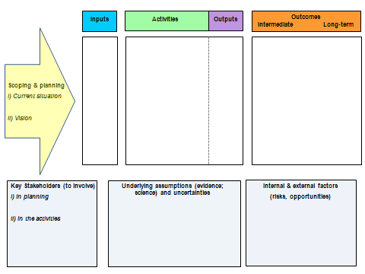
Figure 2 How the eight essential components of a logic or outcomes model (coloured boxes) fit together.
There are eight essential components of a logic model. These are the four primary components of the logic model itself – inputs, activities, outputs and outcomes – and four key supporting activities – key stakeholder analysis, to identify which stakeholders should be involved in model development; the scoping and planning exercise that underpins any model development; ensuring that underpinning assumptions are documented; and noting internal and external factors that may influence outcomes.
There is no single or correct way to draw a logic model. It can be drawn horizontally (as shown in Figure 2) or vertically, either from top to bottom, or bottom to top (e.g. Figure 3). Ideally, a logic model should be able to be displayed on a single page with sufficient detail that it can be explained fairly easily and understood by other people. Much of the value of a logic model is that it expresses visually beliefs about why the programme is likely to succeed through one step leading to another. Thus, each step between an activity and an output or between an output and an outcome can be thought of as an ‘if … then’ statement: ‘If we do/produce X, then we can reasonably assume that Y will follow’.
For large or complex programmes, the logic model may be divided into more detailed sections or sub-models with each of these on a separate page. These may be summarised by a less detailed ‘overview’ model, often given on the first page, that shows how the component sub-models fit together into a whole (see Appendix 2 for an example of a complex model).

Primary components
Terms such as ‘input’, ‘activity’, ‘output’ and ‘outcome’ are the basic language of performance measurement (Table 1). These are explained in more detail here because it is important that there is a shared understanding of their meaning and consistent use of the terms.
Inputs, activities, outputs and outcomes all have performance measures or indicators linked to them so that progress can be measured and reported (see Section 3.5).

Inputs
Inputs are the resources used to produce the programme outputs, and ultimately the outcomes. Inputs typically include such things as money, staff time, accommodation costs, equipment, herbicides and poisons, and information. Inputs are often associated with a cost to obtain and use them, and so programme budgets are essentially lists of inputs and the costs to obtain and/or use them.
Performance measures for inputs are usually counts. These may include hours of staff time, amounts of herbicide or poisons purchased, best practice guidelines, maps, bait stations, survey forms, etc.

Activities
Activities are the actual interventions and actions undertaken by agencies to achieve specified outputs – the uses made of inputs. Activities can range from writing a memo to laying lines of possum traps or spraying weeds, or conducting a survey of ratepayers. Usually, only the critical or most common activities associated with producing the desired outputs are identified in the main logic model. For example, in the relevant DOC logic model, the activity of ‘Animal Pest Ground Control’ when combined with the activity of ‘Animal Pest Aerial Control’ makes up the output ‘Possum Control’. Details of specific activities such as setting and servicing traps can be documented in a sub-model or operations plan.
Performance measures for activities are usually in terms of numbers of traps set, area of weeds spayed, number of meetings held with communities, etc.

Table 1 Terms and definitions for use in logic models describing pest management and linked programmes
Term | Definition
National Outcomes | Desired end state from pest management in New Zealand and linked to high level governmental or regional community priorities  e.g. for DOC, ‘New Zealand’s natural and historic heritage is protected and people enjoy it and are involved with the Department in its conservation’
Outcomes | The results experienced by a system or community from a combination of agency interventions and external factors. Outcome is a general term used to describe the state or change in state of a condition of significance to the system or community resulting from a combination of agency interventions and external factors. Information about outcomes provides a rationale for agency outputs
Outcome Indicators | Measures of the prevailing state in a given period for a specific component of the system or community. They do not show causal links between outputs and outcomes
Intermediate Outcomes | A specified intermediate state that feeds into an outcome. Intermediate outcomes are expected to lead to a desired outcome, but are not the ultimate end result sought. Intermediate outcomes are often used to inform operational or management decisions, and are especially useful when lags in measurable outcomes are significant or limit timely response
Intermediate Outcome Indicators (‘impact measures’) | Measures of the difference made by the delivery of outputs – the impact. These measures focus on effectiveness
Outputs | The goods or services that are produced by a department/agency
Output Performance Measures | These focus on delivery of outputs. They provide information on efficiency of operations (the ability to do the same work to a consistent standard continually over time)
Activities | Actual interventions undertaken by agencies to achieve specified outputs. An output is made up of a number of activities: e.g. in DOC, the activity of ‘Animal Pest Ground Control’ when combined with the other activity of ‘Animal Pest Aerial Control’ makes up the output of ‘Possum Control’
Methods | Activities are made up of a number of methods, e.g. trapping, hand-laid bait, and bait-stations in the DOC activity of ‘Animal Pest Ground Control’
Inputs | The resources (such as capital, personnel, accommodation, equipment, information and time) used to produce outputs and to achieve outcomes
Monitoring | Monitoring is the measurement of change in a natural environment, e.g. the abundance and distribution of weed and pest populations over time. Monitoring enables staff to evaluate the progress and success of programme

Outputs
Outputs are the tangible results of the major activities in the programme. They are the goods and services produced or delivered by the programme, such as possum control, weed control or public awareness. An output usually involves several activities. For example, possum control might include the activities of trapping and poisoning; weed control might include the activities of spraying and physical destruction; public awareness might include the activities of holding meetings with communities and phone surveys.
Performance measures for outputs are usually a count or number; for example, the number of possum control operations meeting target RTC, numbers of reports produced and newsletters published. These measures are commonly used by councils for reporting, so we do not go into them further in this guide.

Outcomes
Outcomes are the desired states of the community, biological system or production sector that the programme aims to achieve. Examples include improved ecosystem health, increased native bird numbers, reduced crop losses to bird pests, and local communities more aware of and contributing to pest control. Outcomes are usually specified in terms of:
Conditions (biological or physical changes in a system)
Learning, including enhancements to knowledge, understanding, perceptions, attitudes and behaviours (‘social’ outcomes)
Skills (changed behaviours to accomplish results, or capabilities)
Outcomes may be specified as short-term, intermediate and long-term, or just intermediate and long-term. A long-term outcome often has intermediate outcomes that together contribute to the ultimate achievement of the long-term outcome. The outcomes of regional council pest management programmes should contribute explicitly to the region’s community outcomes as specified in the council’s annual plan or LTCCP/LTP.
An intermediate outcome is a specified intermediate state that contributes to the desired long-term outcome – a step along the way. Intermediate outcomes are especially useful when time-lags in measurable outcomes are significant or limit timely response. For example, a long-term outcome about restored ecosystem health through pest management may require separate intermediate outcomes about increasing native animal numbers and habitat restoration, to which the activities of possum, predator and weed control and replanting would all contribute.
The difference between outputs and outcomes is particularly critical. Delivery of outputs tells us about programme efficiency, but not about its effectiveness. For example, a pest management programme may kill many possums (output), but that does not necessarily tell us that native bird numbers have increased or forest canopy condition has improved (outcomes).
For large or complex programmes, a logic model may be divided into key work streams, which are often based on generic groups of activities such as programme management, operations, monitoring, community engagement, each with its own set of intermediate outcomes (see the national Didymo Long-term Management Plan model in Appendix 2 for an example). Intermediate outcomes may feed into each other and the time required to achieve intermediate outcomes may also differ. This means that the logic model may not always be a simple linear hierarchy (see Figure 3).
For agencies, such as regional councils, that manage a considerable number of programmes, it would be a large and complex task to produce a logic model for every programme. One solution would be to develop a model for each class of pest where similar activities (e.g. weed spraying) are used to produce similar outputs for achieving similar outcomes (e.g. improved pasture productivity). At each stage of the model, a link can be added to show which measure is used and where that measure is reported.
Performance measurement for intermediate outcomes is done using impact measures or indicators, discussed in detail in Section 3.4.3. These measures of intermediate outcomes are crucial to the performance measurement process, because they underpin performance-based management by demonstrating the difference that a programme is making at a measurable timescale (NZ Treasury and State Services Commission 2008).

Supporting information for logic models
A logic model requires four key sets of supporting information and activities so that the model and the intended programme can be understood in their wider context.

Stakeholder analysis
The process of developing a logic model is an opportunity to engage your stakeholders in a discussion about the programme and to get their input to the process. Stakeholders might include programme staff, clients, partners, funders, board members, community/iwi representatives, and volunteers. Their perspectives can enrich your programme logic model by clarifying expectations for the programme.

Planning and scoping
Programmes are created to address particular perceived problems or needs. The first step in creating a logic model for a programme is to define clearly the problem or need. An ‘issue’ statement should explain briefly the current situation: what needs to change; why is there is a need for intervention; and, what problem/issue does my programme aim to solve?’ This requires that ‘who, what, why, where, when, and how’ are all considered in relation to the problem/issue.
Then, the overall purpose of the programme needs to be defined. What are you trying to accomplish over the life of the programme and beyond? The answer to this question is the solution to your issue statement, and will serve as your programme’s vision. The programme vision serves as a reference frame for all elements of the logic model that follow. The desired long-term programme outcomes can then be developed naturally from the information in the vision and issue statements. The long-term-outcomes statement should include the intended change that results from the programme or initiative, and specify the target population you intend to serve (see Figure 3 and Section 3.4). An alternative approach could be to use the LTCCP/LTP outcome to which the programme contributes in place of a programme-specific vision statement.

Assumptions and uncertainties in the links between outputs and outcomes
The link between a programme’s activities and outputs and its desired outcome is based on a ‘theory of change’ – that is, why successful delivery of output X is expected to lead to a desired change, i.e. outcome Y.
A ‘theory of change’ may be based on:
Wisdom and experience: your previous experience leads you to believe that this set of actions will lead to your intended outcome
Research and evaluation: formal research indicates that this set of strategies has been successful in achieving your intended outcome
Best practices: well-regarded and successful programmes in the field use these strategies to achieve the outcomes you are seeking
It is important to identify and record the theory of change on which your logic model is built. The first step is to document your programme rationale – the beliefs about how change occurs in your field, based on research, experience, or best practices. The next step is to identify the assumptions that are built into your programme rationale and to acknowledge and document where uncertainties, perhaps due to research gaps, exist.
Assumptions may be biological – for example, the Didymo (Appendix 2) and other freshwater pest programmes are based on the assumption that compliance with the ‘Check Clean Dry’ guidelines will reduce or stop the spread of most freshwater pests. Assumptions may also be social – for example, we assume that behavioural change is a process and people move through a number of predictable steps as they move through this process. What is important is that these assumptions are documented, and that they support the underlying logic of the steps in the programme ‘chain’ from inputs to outcomes.

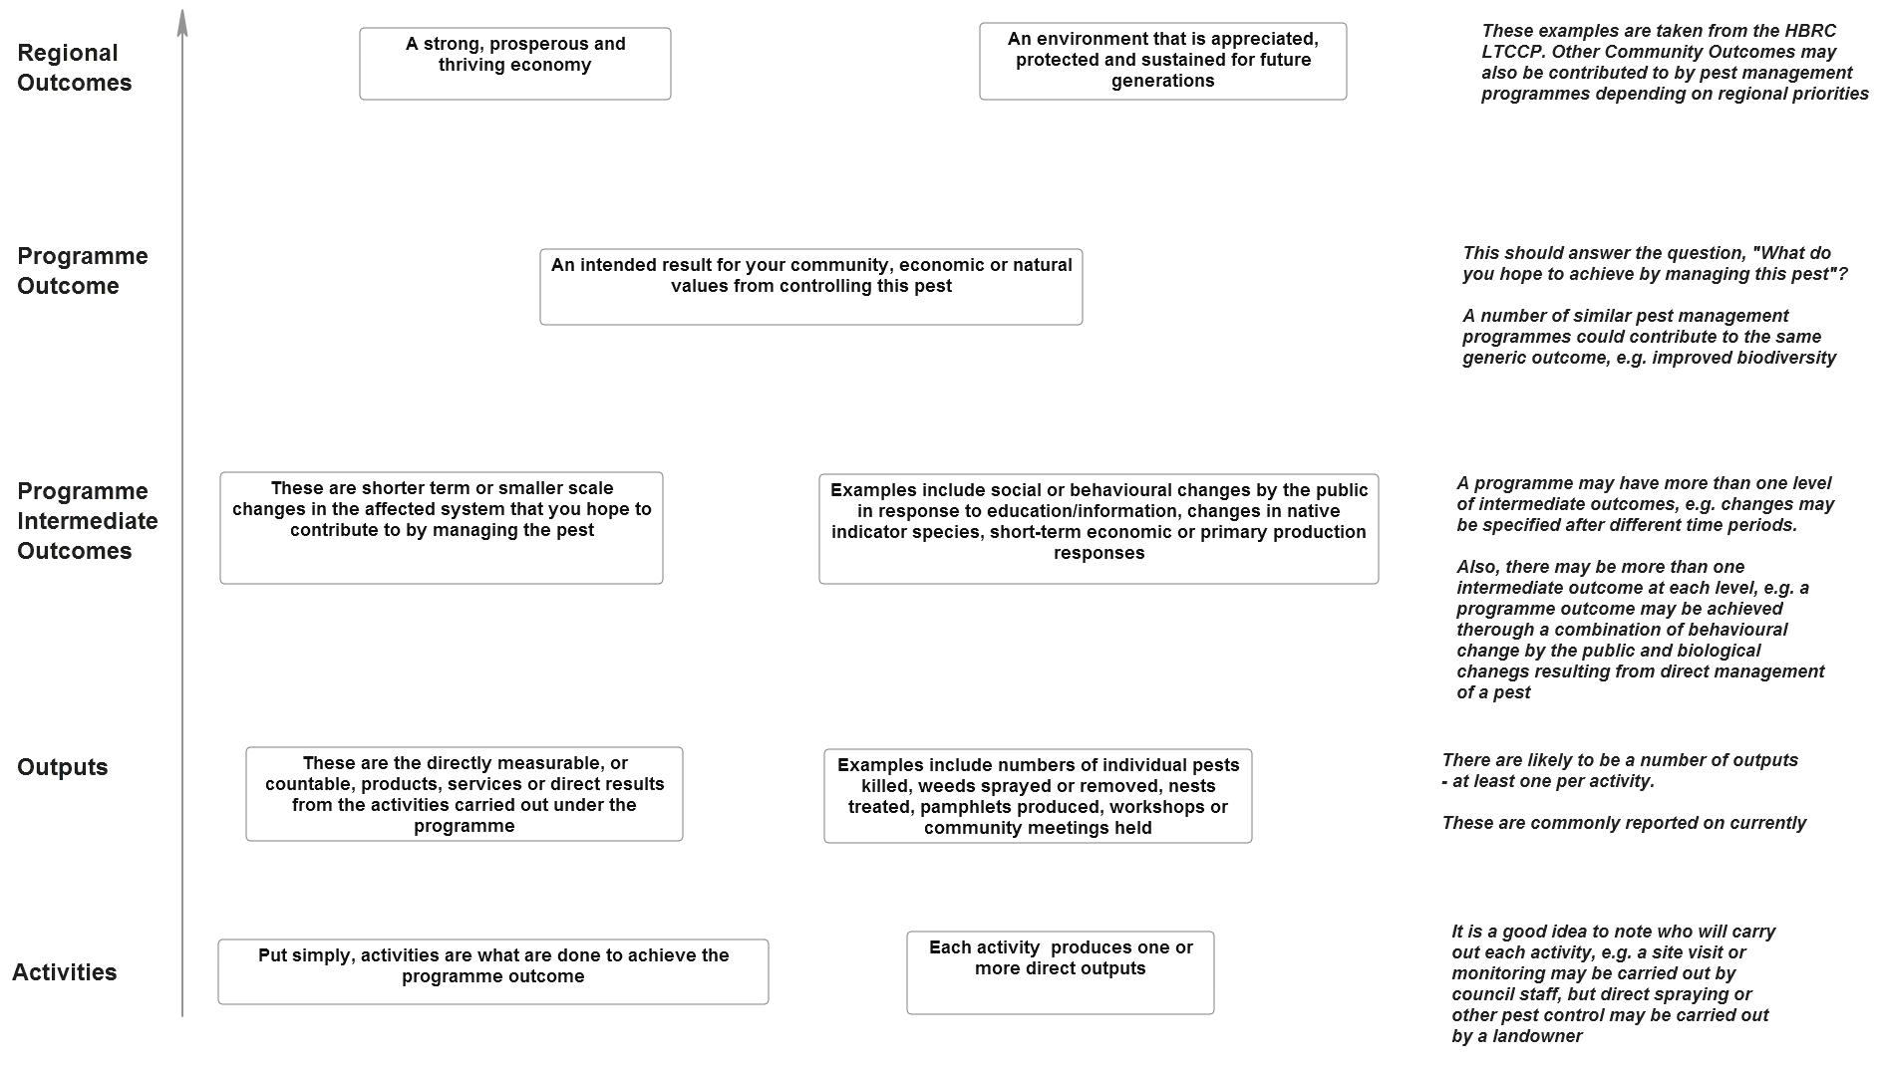
Figure 3 Basic structure of a logic model for a regional pest management programme. The model is read from bottom to top and arrows or connecting lines can be added to show linkages between lower and higher level components.

Internal and external factors affecting outcomes
Many factors over which you have little or no control may affect your programme’s outcomes. These may be both internal and external, and may help or hinder a programme’s outcome. Knowing or anticipating changes in any of these factors may help trigger programme adjustments in advance of problems. It is therefore important to undertake an analysis of the key risks to achievement of outcomes and put in place strategies to mitigate those risks. It can also be useful to identify potential opportunities that may enhance your efforts in the future (e.g. potential for cross-programme or inter-agency collaborations, or favourable resource reallocation).
Typical internal risk factors include such things as staff capability, management decision making, resource allocation priorities, and other things related to the immediate organisational environment. Typical external risk factors and opportunities include such things as the political environment, the economic situation, social attitudes, and geographic and other natural constraints/drivers/controls. Consideration of risk factors may include asking questions such as:
Is the current political environment supportive of your programme strategies?
Are there economic barriers to achieving the outcomes?
Is community support for the programme a critical component? If so, are there political or economic characteristics that will influence the community and affect your programme?
Is bad weather likely to interfere with programme activities and affect outputs?

Common headaches for logic models: attribution and time-lag
The complexity of natural resource systems may create challenges in demonstrating progress towards outcomes. Two of the most significant problems are time-lag and attribution.

Time-lag
Long-term outcomes for biological resources affected by pests, especially native biodiversity, tend to be achieved gradually, sometimes over many years. Performance reporting and programme review usually take place at shorter intervals (e.g. annually), so the challenge is how to show meaningful progress towards long-term outcomes over relatively short time frames. Performance measures and indicators may also fluctuate due to background ‘noise’ such as seasonal changes and other extraneous factors. A good approach to address the time-lag challenge is to break the end outcome down into more tractable levels, using intermediate outcomes amenable to demonstration of shorter-term progress (Figure 3).

Attribution
Attribution (the link between cause and effect) is part of ‘theory of change’ described in Section 2.4.3. Uncertainty in attributing cause and effect can be expressed on two levels – first, how can we be completely certain that today’s pest management inputs and outputs will lead to the desired outcomes at some future time?: and, second, even if the desired outcomes occur, how can we be certain that the pest management intervention was the primary cause?
To address this ‘challenge of causal attribution’, the programme logic model needs an accompanying ‘performance story’ that:
Argues convincingly, and based on strong evidence wherever possible, that activities and outputs are likely to contribute to ultimate outcomes (the programme’s documented theory of change)
Demonstrates that activities and outputs are contributing to outcomes at some more measurable level (intermediate outcomes and their associated performance indicators)
Communicates clearly and explicitly the logical steps in linking inputs to outcomes
The existing literature on the science and practice of pest management, ecology, and biodiversity conservation contains much valuable information about the success and failure of past management activities. This information can provide managers with varying levels of support for the causal pathways that may be proposed in logic models (The Heinz Center 2009).
Approaches to addressing issues of attribution and time-lag include:
- Robust, justifiable and documented links in a programme’s logic hierarchy (i.e. is it reasonable to assume a cause–effect relationship, based on prior evidence?)
- A focus on intermediate outcomes that can be attributed directly to programme activities at a measurable timescale; use of qualitative measures of progress (e.g. feedback or anecdotal reports of change from a significant number of stakeholders)
- Use of a formal experimental design or a statistical analysis of attribution
Councils are most likely to rely on approaches 1 and 2 because of the cost of data collection and analysis required for approach 3.

Building logic models

Overview
A useful sequence to begin to develop a logic model is:
- Consider how to involve key stakeholder groups to capture their essential knowledge/perspectives
- Undertake scoping and planning: define the programme boundaries – develop issues and vision statements
- Develop a set of outcomes and, if required, intermediate outcomes
- Identify associated outputs, activities and inputs
- List assumptions, and undertake risk assessment of influential internal and external factors
- Develop appropriate indicators and measures for performance measurement and incorporate these in a monitoring and evaluation plan
It is not essential to create your logic model in one sitting. Sometimes, especially for programmes that are well underway, it may be easier to identify what activities you are already implementing, and then add in the other components to check the logic of the current activities. A sample worksheet to get started on developing a logic model (based on Figure 2) is available here hyperlink.
We would emphasise again that there are many ways to portray the components of a logic model and this worksheet is provided just as a way to get started.
This section covers the first five steps in developing a logic model. The final step: developing and using an evaluation plan, is covered in Sections 4 and 5. In order to illustrate the process of building a logic model for a programme we use two case studies, one based on a control programme for saffron thistle, a plant pest with economic impacts, and the other on a regional possum control programme.

Involving stakeholders
The level of engagement with stakeholders in developing a logic model is likely to depend on the significance of a particular programme (in terms of net spend and value or interest to the community). Clearly, stakeholder engagement and consultation is not going to be a practical reality for some programmes, but in this section we describe a process that is appropriate for a significant programme.
Consider the range of stakeholders that may affect the programme, particularly those stakeholders who will be participating in, or influenced by the programme. Engage with groups who may either support or inhibit progress towards the programme’s outcomes. Having both complementary and competing points of view at the table ensures that a variety of perspectives are represented.
It may be helpful to form a joint team or advisory group with key stakeholders for logic model development. This process encourages different groups to develop a common understanding about programme outcomes and limitations, as well as activities to achieve those outcomes and future directions.
Some benefits of involving stakeholders in the development of a logic model are:
Provision of a forum for stakeholder perspectives and views (whether similar or opposing) to be identified and considered
Promotion of ownership, commitment, and support to the programme from all stakeholder groups
Encouragement of ‘buy-in’ from stakeholders to the programme
Provision of access to a broad range of knowledge, perspectives, and resources from the stakeholders that bring their own expertise to the table
Facilitation of future actions based on the project results and recommendations

Scoping and planning
For much of pest management carried out by councils, the community outcomes may already be set in the LTCCP. The process outlined here can be used to scope and plan a programme’s outcomes and intermediate outcomes to deliver on the LTCCP community outcomes. The challenge is to contribute meaningfully to the community outcomes through the change you want to achieve over the life of your programme. Be specific, so that the community outcome provides guidance for your programme.
Understanding a system or community’s current state and needs is the foundation for logic model development. The problem or issue to be addressed sits within a setting or situation: a complex of socio-political, environmental, and economic conditions. If you misunderstand the situation and therefore misdiagnose the problem, everything that follows is likely to be wrong.
Take time to understand the situation and define the problem carefully by considering the following questions.
What is the problem/issue?
Why is this a problem? What is causing the problem?
Who (individual, household, group, natural system, community, society in general) has a stake in the problem? Who cares whether it is resolved or not?
What do we know about the problem/issue/people that are involved? What research evidence and/or experience do we have in addressing this or similar issues?
Create a succinct but thorough vision statement that answers the above questions. Include the intended results, in general terms, of the programme. This statement is the foundation of your logic model, and the basis of your outcomes. Having a clear and agreed vision helps fight the temptation to implement an interesting programme that may not deliver the desired outcome.
Other key considerations in this phase include defining assumptions and risk factors that might affect the programme:
Is the programme’s end outcome achievable in the time frame?
Who are the key end-users and stakeholders?
Are there robust cause-and-effect links to justify interventions?
What outputs are likely to be required?
What are the costs likely to be?
Are sufficient resources likely to be available?

Scoping and planning – Example 1. Saffron thistle
Current situation
Primary impact – pasture productivity; current low impact due to control, but without control could lead to significant economic impact
Occurs as small infestations scattered throughout the region
Found predominantly in summer-dry pastureland and can form impenetrable stands that remain over winter
Designated as a Total Control (Occupier Responsibility) plant pest; council may assist in control of small patches or partially subsidise larger programmes
Large, high density patches require aerial control, otherwise ground control
Seed dispersal is mainly by stock wool or hair, machinery, and water; not by wind, as seeds are too heavy. Seed bank very long lived
Landowner compliance is patchy
Key stakeholders:
(i) in planning
Regional council
District councils
Land occupiers
Iwi
Federated Farmers
Crown Research Institutes
(ii) in the activities
Regional council
District councils
Land occupiers
Iwi
Contractors
Vision
Significant adverse effects of saffron thistle on the economic well-being and recreational values of the region are prevented by containing infestations to their present sites.

Scoping and planning – Example 2. Regional possum control
Current situation
Impacts: economic through browse pressure on pasture, young plantations and crops; as vector of bovine TB, and on biodiversity via direct predation on native plants, insects and birds
Currently at <5% residual trap-catch over 90% of the region, but high density pockets remain on Crown land and margins
Designated as Regional Control Pest: control is through establishment of Possum Control Areas where council manages initial control; occupiers responsible for ongoing maintenance
Also significant target pest in site-based biodiversity community pest control programmes
Key stakeholders:
(i) in planning
Regional council
District councils
Occupiers
DOC
Federated Farmers
SPCA
Iwi
CRIs
(ii) in the activities
Regional council
District councils
Occupiers
DOC
MOH (consents)
Forestry managers
Contractors
Forest user groups (F & G; F & B; hunters)
Vision
The adverse effects of possums on biodiversity and economic prosperity in the region are minimised.

Developing outcomes

Outcome statements
Once a vision for the programme is agreed, the next step is to develop outcomes to address it. The programme outcomes and intermediate outcomes should be structured in a logical hierarchy reflecting how each leads to another and/or contributes to the long-term community outcome(s). A useful way of doing this is to take each outcome and ask the question, ‘If we achieve this, what will it lead to and how will it contribute to the long-term outcome?’ Look for gaps – starting from the highest level outcome and working down the outcomes model. A test is being able to read an outcome and say, ‘Yes, this will be achieved if we achieve all of these outcomes (and outputs) below it.’ The answers to these questions will enable you to draft a succinct statement of each outcome.
An outcome can also be no change in the current satisfactory state of a system that is threatened by a pest, for example, where the pest exists at low levels in the region, but without a control programme could rapidly increase its range and/or density and thereby have a significant impact on a system.
Each outcome statement should therefore define what will change as a result of an intervention and by how much (or, at the very least, in what direction the change will occur). This then allows the means of performance measurement to be defined. If an outcome statement specifies a desired change in precise and unambiguous terms, the appropriate indicator or measure can be defined with similar precision. Examples are given in Table 2.
Some ways to do this include:
Consider the impact caused by the targeted pest (or pests). What would the system (ecosystem, production system etc.) be like if the pest did not exist or its impacts had not occurred? That is your outcome.
Ask yourself: What is/will be different as a result of the initiative? For whom? What will be changed/improved? What do/will beneficiaries say is the value of the programme?
Think about what you want to be able to say to your council or the ratepayers who finance your programme. What would you want to say to your CEO? If you could write a news release about your programme, what would the headline be? Your answers to these questions are most likely outcomes.
For an existing programme, look at all the programme’s major activities. For each activity, ask yourself, ‘Why are we doing that?’ Usually, the answer to the ‘Why?’ question is an outcome.
Seek ideas and input from others. Their perspectives will help provide a broader understanding of the programme and its benefits. This activity will also help build consensus among key programme stakeholders. You might talk with current and past participants, funders, peers, local officials, board members, and informed outsiders.
Review existing programme statements and adapt, if necessary, to an outcome format.

Key tips for writing outcomes
Describe the desired change.
Be succinct (aim for max.10 words).
Say ‘what’ not ‘how’. The ‘how’ is a later step.
Define the key terms used in the statements.
Use plain English words in the statement – to avoid ambiguity.
Remove all excess/unnecessary adjectives that could increase the difficulty of measuring outcomes.
Identify suitable and practicable ways to measure achievement of the stated outcomes.
Test that outcomes are likely to be achieved in the programme time frame (within the resource allocations and reporting periods).
Keep outcomes SMART : Specific, Measurable, Achievable, Relevant, Time-limited.
Table 2 Examples of outcome statement structure from a range of sectors
Who/what | Change/desired effect | In what | By when
Key native species | Increase | Numbers | Within 5 years of the project start
Primary production | Increase | $ value | Over 10 years
Native canopy cover | Increase | Trend | Over 5 years
Seabird-dominated coastal ecosystems in Northland | Increase | Extent | 2035
Public awareness | Increase | Extent | Over 5 years

Importance of intermediate outcomes
As discussed in Section 2.3.4, achievement of outcomes may be a long-term process. Intermediate outcomes allow a short-to-medium term assessment of the difference that outputs are making to outcomes.
Progress towards intermediate outcomes is measured using impact measures or indicators (see Section 4.1). These measures of intermediate outcomes are crucial to the performance measurement process, because they underpin performance-based management (N.Z. Treasury and State Services Commission 2008). Specifically, they:
Allow time-lag and attribution issues to be mitigated
Represent near-term changes expected from the goods and services you deliver
Can often be measured soon after delivery, promoting timely decisions
Often reveal specific ways in which managers can remedy performance shortfalls
Are of immediate interest to decision-makers at all levels of your agency
Table 3 (also the didymo example in Appendix 2) shows how multiple intermediate outcomes can be used to measure progress towards a longer-term outcome using steps that are measurable at common reporting and programme-review timescales. Without these it would be very difficult to demonstrate the link and any progress towards the programme outcome resulting from the activities.
Table 3 Measuring progress using intermediate outcomes to aid reporting and demonstrate attribution of change to pest management programme activities. Note that the logical link between the output level and the programme outcome would be very weak without the intermediate outcomes
Outcome | Harm to economic activity from pests and diseases is prevented or reduced | Outcome indicator | Trend in a set of economic measures for the primary production sector
Intermediate outcome I | Increased stock productivity within 10 years of programme commencing | Intermediate outcome I indicator | Kg of product per hectare (e.g. milk solids, meat) over a 5-year period
Intermediate outcome II | Increased pasture growth within 2 years of programme commencing | Intermediate outcome II indicator | Pasture dry matter yield per hectare over a 2-year period
Output | Weed control | Output performance measure | Weed species distribution and density
Activity | Spraying/grubbing | Activity measure | No. of plants removed / area sprayed
Input | Labour, herbicide | Input measure | Costs; staff FTE

Outputs, activities and inputs

Outputs
Outputs are the measurable, tangible, and direct products or results of programme activities, such as possum control or weed control, or public engagement. Output measures tell you how well you are delivering the programme, but not whether your efforts are making any difference to the affected natural or production system.
Whenever possible, express output measures in terms of the number, size and/or scope of services and products delivered or produced by the programme. Output measures frequently include quantities or reflect the existence of something new (i.e. something that the relevant activity has produced). In the latter case a simple presence/absence indicator could be appropriate.
Examples of programme output measures include numbers and/or descriptions of:
Changes in pest numbers resulting from pest control operations
Meetings held
Materials developed or distributed
Hours of service provided
Partnerships or coalitions formed
Focus groups held
Check that your outputs have activities and inputs associated with them. This is one way a logic model is useful: to check whether all the necessary activities and resources have been identified to create a product or deliver a service successfully.
Many people identify specific targets and time frames for their outputs (this is equivalent to specifying ‘service delivery’ targets for a period). Begin with an estimate, based on experience, desired impact, and inputs available. Don’t get stuck on exact numbers – you can adjust them with experience.
It is critical not to confuse outputs and outcomes. Outputs relate to ‘what we do’. Outcomes refer to ‘what difference is made’.
Examples of outputs include:
Outreach events
Weed control
Possum control
New publications
Examples of output measures might include
Number of outreach events held
Number of weeds killed or area over which control was effective
Number of possums killed or operations meeting target post-control residual trap-catch (RTC)
Number of publications produced and/or distributed
Outcomes linked to these outputs may be:
Behavioural change in people attending events
Increased pasture productivity
Healthier forest canopy
New or amended public policy

Activities
Activities are the actions undertaken to deliver on outputs. A list of activities helps people who are not familiar with your programme to understand what it takes to implement it.
Common pest management activities are:
Setting traps or poison bait stations
Spraying/grubbing weeds
Visiting landowners/garden centres
Running meetings and workshops for community groups
Developing products (e.g. promotional and educational materials)
Engaging in policy advocacy (e.g. issuing policy statements, conducting public testimony)
Building infrastructure (e.g. strengthening governance and management structures, relationships, and capacity)
A large programme with several outputs may have numerous associated activities; smaller programmes may consist of just one or two. Related activities can be grouped together. The activities identified can be used as headings in a more comprehensive work plan that includes staff assignments and timelines.
Activity measures might include
Number of lines of possum traps set
Area of weeds sprayed
Time spent organising outreach events
Time spent drafting policy advice

Inputs
Inputs are the resources and contributions that you and others make to pest management. These include time, people (staff, volunteers), money, materials (e.g. herbicides, toxins), equipment, office/storage space, information technology resources, information, and technology. Collectively, these inputs should cover all the requirements to ensure successful delivery of activities and outputs. You can use your input list as the foundation for developing a programme budget. In-kind contributions are also often overlooked, but should be included in inputs.
Input measures might include
Quantity of herbicide purchased
Staff salaries (or FTE)
Equipment used

Assumptions and uncertainties
The assumptions that underlie a programme’s theory of change are conditions that are necessary for programme success, and that you believe are true. Your programme needs these conditions in order to succeed.
Your understanding of how things work (theory of change) may arise from:
Research and evidence base (both biophysical and social science)
Best, or promising, practices
Local knowledge and wisdom
Matauranga Māori
The assumptions that link each step in your programme logic model to the next (i.e. the, ‘if we do X, then Y will result’ links) should be documented when scoping a new programme or reviewing an existing programme. When programmes are reviewed, these assumptions should also be reviewed in the light of new information and modified accordingly to improve overall performance.
The links between logic model steps should, ideally, be based on strong defensible evidence. In listing the assumptions, it is useful to indicate the strength of the evidence on a simple scale; for example:
- No support: the proposed sequence of events has not been documented previously.
- Weak support: the sequence of events in the logic model has been documented at least once in the real world.
- Stronger support: a causal relationship has been demonstrated between the outputs proposed and the intended outcome.
- Strongest support: it has been demonstrated that the proposed outputs will lead to the proposed outcome with a high degree of probability.
It is also important to note early in the process what you don’t know. Acknowledgement of where uncertainties lie can help you review your programme critically at the appropriate time.

Internal and external influencing factors
A range of internal (within the programme or agency’s control) or external factors may have positive or negative influences on a programme’s outcomes. These correspond to risks and opportunities. Identifying and listing these factors is the first step in developing plans to mitigate risks, and see where to work with other parties, to help assure the programme’s success.
External factors include: weather; natural events (e.g. landslips, floods); changes in local or national government policies; the activities of related programmes; economic factors; ecological effects (e.g. natural changes in resource availability or pest responses); public opinion
Internal factors include: programme management decisions; level of funding; quality of delivery; staff selection; methods used; training requirements.

Final checks
Your logic models should be reviewed carefully before the associated monitoring and evaluation programmes are developed and implemented. The review should ask the following questions.
Do the steps in the model make logical sense?
Do the outcomes seem reasonable, realistic and comprehensive, given the scale and scope of the activities that are being proposed?
Do the downstream steps follow logically and necessarily from the steps that are earlier in the chain?
Are there any major leaps in the logic or process assumptions that have not been stated explicitly?

Practicalities
Some pest programmes may involve a number of groups of activities such as direct control, monitoring and community engagement, which, in turn, may lead to a number of outputs and intermediate outcomes. The graphical representation for such a programme may appear quite complex and such detail may be best placed in an appendix to the main body of, for example, a Regional Pest Management Plan document. If this is the preferred option, the essential features of the programme could be summarised in a table beneath the description of each pest.
Building a logic model Example 1. Saffron thistle

Community outcome(s) to which this programme contributes
A strong, prosperous and thriving economy (from regional annual plan)
Programme outcomes
A. By 2025 saffron thistle control costs on at-risk farms are reduced by 50% compared with 2012 baseline costs.
B. By 2050, at-risk farms suffer no pasture productivity losses due to saffron thistle.
Intermediate outcomes
- By 2022, the density of saffron thistle infestations on affected properties has declined by 15% compared with 2012 baseline.
- By 2027, the number of properties requiring aerial control of saffron thistle has declined by 50% compared with 2012 baseline.
- By 2022, 90% of occupiers of infested properties use best-practice saffron thistle control methods.
- By 2017, an affordable adaptive management programme for saffron thistle is in place and reviewed annually.
Activities and their outputs
- Engagement activities [farm visits, field-days; educational media]
- Surveillance and monitoring [maps, database – distribution and plant-count data]
- Control operations: aerial and ground spraying; grubbing [plants killed/removed]
- Programme management: regulatory; planning; contract management; database maintenance [RPMS; reports, contracts; regulations; enforcement notices]
- Research: novel control methods; dispersal modelling [new control tools; reports]
Assumptions and uncertainties
- Control programme is maintained and supported
- Farmers are responsive to engagement activities
- Saffron thistle remains in the RPMS
- Control tools remain available and effective
- Survey methods are sufficient to map density and distribution of saffron thistle
- Land-use practices are maintained
Other influential factors
- Maintenance of funding
- Political and community support for programme.
- Climate change

Building a logic model Example 2. Regional possum control
Community outcome(s) to which this programme contributes
A strong, prosperous and thriving economy
An environment that is appreciated, protected and sustained for future generations
Programme outcomes
A. By 2017, primary production has increased by at least $1.00/ ha/yr over the regional possum control area, relative to 2012 values.
B. Average occupier costs of possum management are maintained below $2.50/ha/yr over the regional possum control area.
C. By 2050, possum-threatened biodiversity values in the region have improved by at least 20% compared with 2012 baselines.
D. At least 90% of occupiers undertake effective possum maintenance control on affected urban properties by 2022.
Intermediate outcomes
- By 2016, relative abundance of possums is maintained ≤ 5% residual trap-catch over the PCA
- By 2025, preferred possum-browse species in native bush remnants suffer minimal impacts from possums
- Monitored native bird species have increased in distribution and abundance in the region by 2022
- By 2015, 90% of urban residents are aware of the biosecurity risks of possums and support possum management activities
- By 2017, an affordable adaptive management programme for possums is in place and reviewed annually
Activities [and their outputs]
- Engagement activities [farm visits, field-days; educational media]
- Surveillance and monitoring [maps, database]
- Control operations: bait station and trap-line deployment and maintenance [possums killed]
- Programme management: regulatory; planning; contract management; database maintenance
[RPMS; reports, contracts; regulations; enforcement notices]
Assumptions and uncertainties
- Control programme is maintained and supported
- Farmers are responsive to engagement activities
- There is a pastoral economic benefit from possum control
- Control tools remain available and effective
- Survey methods are sufficient to map density and distribution of possums
Other influential factors
- Maintenance of funding
- Political and community support for programme
- Toxins, in particular, remain effective in controlling possums
- No significant human or ecosystem health risks from use of toxins
- Possum control and tools used remain acceptable to the public
- Land occupiers continue participation in programme

Assessing progress and performance

Performance measures and indicators
Once a logic model has been constructed for a programme, the next step is to associate each component of the model with one or more measures or indicators that allow progress and performance to be assessed. Generally, the term ‘measure’ is used for metrics that can be counted directly (usually applied to inputs, activities and outputs); the term ‘indicator’ is used for intermediate outcomes and long-term outcomes because the performance metric is a more or less indirect measure of the actual outcome. For example, in our example of a possum control programme, the indicator of the outcome ‘increased primary production’ is pasture dry matter yield, whereas the measure for the activity ‘bait stations set’ is the actual number of bait stations deployed.
Both measures and indicators may be quantitative or qualitative – in some cases a combination of both types may be appropriate. Usually, you should identify one to three measures or indicators for each level of the logic model from activities to outcomes. If qualitative measures are used, they should be set up using a formal rating scale (e.g. zero, low, medium, high; or, rarely, occasionally, commonly, frequently), and each step on the rating scale should be defined to ensure consistent application by different people and at different reporting times. For example, people could be asked to rate their satisfaction with a workshop on a scale of 1 = waste of time to 5 = met all my expectations or farmers could be asked their views on whether damage to crops had been reduced after pest bird control on a scale of 1 = worse than before control, 2 = no change or 3 = better after control. An alternative to assigning a numerical value to qualitative information would be, for example, for field staff to note landowner satisfaction and observations of resource condition during routine discussions of the project.
Development of performance measures and indicators can seem a huge and complex undertaking, especially for pest management programmes that may contribute to a range of economic, social and environmental outcomes. It is impossible for agencies to measure everything, so it is important to identify what has been termed the ‘vital few’ measures and indicators that can jointly provide a general assessment of performance of the programme. Selection of the vital few in the context of the regional pest management plan or strategy may mean selecting a set that represents the range of social, economic and environmental outcomes or the range of pest classifications or programme types. Any requirement for performance measures and indicators to align with those used at the national level or across regional or regional–Crown boundaries may also need to be taken into account.
The overall process of assigning performance measures and reporting links to each level of the logic model is summarised in Figure 4.

What are good measures and indicators of progress?
Whatever measures you use should allow assessment of progress at each level of the logic model. While all levels of the logic model should have associated performance measures and indicators, those attached to the intermediate outcomes are among the most important. They provide key information on the effectiveness of the translation of outputs to outcomes.
The key rules for developing a set of performance measures and indicators are:
Be certain about what you want to measure – you need to be clear about what you want to measure or you will struggle to find a good measure.
Less is more – it is important to paint a clear picture or progress, so don’t confuse things with too many measures.
Valid and meaningful – there must be a clear link between the indicator of progress and the outcome, and the measure must be appropriate to reporting needs.
Be transparent – record how and why you selected the measures to be used.
Documentation – record definitions of the measures, the data sources used for the measure, and any data limitations or assumptions.
For activities and their outputs, performance measures are usually direct counts such as how much, how many, how good, or how quickly. This type of information is already collected and reported in most programmes. Key measures of outputs typically assess quality, quantity, targeting, timeliness, location, cost and coverage.
For outcomes, clear, well-written outcome statements make the choice of performance indicators relatively straightforward. For a weed affecting agricultural production and causing crop losses, intermediate outcome indicators might be about increased productivity at treated sites, or reduced expenditure by landholders on weed control. For a weed affecting biodiversity values, intermediate outcome indicators might be about changes in bird counts, seedling densities, etc. For measuring change in biodiversity values, selection of appropriate indicators from the Regional Council Terrestrial Biodiversity Monitoring Framework (Lee & Allen 2011) is recommended to facilitate consistency of data collection within and between agencies. These indicators are listed in Appendix 3. Some indicators may be able to be used to inform on progress towards more than one outcome.
Where possible, indicators should have associated ‘targets’; that is, the magnitude of the change expected in the indicator over a specified time frame; for example, a 10% increase in productivity within 5 years at sites where weeds are treated. Performance measurement is essentially the comparison of actual indicator values with target values. The indicators to be used to assess the performance of a programme can be noted on the logic model diagram so that the reader sees very clearly how progress will be measured.

Choosing ‘the vital few’ measures and indicators
One approach to selecting ‘vital’ measures and indicators is to develop draft measures and indicators and then asses them against the following set of criteria. Measures rejected in this process can be kept in reserve and possibly used later should any in the final set prove to be unfit for purpose.
Does the indicator reflect performance or progress towards the outcome or intermediate outcome adequately?
Is the indicator practicable?
Can data for the indicator be obtained regularly so that trends can be tracked?
Is the indicator likely to be sensitive enough to track meaningful change between reporting periods?
Is the indicator easy to understand and meaningful to stakeholders?
Will the indicator be useful for a range of audiences?
Are source data readily available, or are they likely to become available in the short-term?
Is the indicator defensible to a technical audience?

Proxy indicators
Sometimes it may not be practicable or realistic to measure a programme outcome or intermediate outcome using an indicator that informs directly about the outcome. There may, for example, be a significant lag between the time when action is implemented and a response, or it may be impractical to use a direct indicator for cost or other reasons. In such cases, it is necessary to use a ‘proxy’ indicator that provides information, albeit indirectly, on the outcomes. Such proxy indicators are usually those aligned with the logic model one or two steps back from the outcome level, e.g. output measures. For example, a weed may be controlled to achieve an outcome such as ‘people are protected from harmful health impacts of weeds’. An obvious indicator would be the number of cases of weed-induced illness. If such statistics are not available or would be too costly to collect, then a suitable proxy indicator such as ‘changes in distribution and density of the weed’ might be appropriate, given the reasonable (logical and evidence-based) assumption that reducing weed density and distribution will reduce cases of weed-associated illness. A report by Cowan (2010) discusses the rationale for proxy indicators in relation to some of the Hawke’s Bay Regional Council pest management outcomes.

Protocols for indicator measurement
It is critical that well-designed data collection protocols are used for performance measures and indicators. This is not only so that high quality, robust data are obtained, but also so the contribution of activities and outputs to outcomes can be demonstrated clearly (i.e. the issue of attribution). Protocols might include, for example, field methods such as five-minute bird counts, foliar browse index, crop loss estimates and also associated data management and analysis methods. Issues with adequate design of measurement protocols are discussed in detail by Clayton and Cowan (2009) who recommended that councils consider a common set of output and outcomes measures for pests that are managed by multiple councils. DOC currently has standard protocols for many of the methods used to assess changes in pest number and biodiversity (www.doc.govt.nz/conservation/threats-and-impacts/animal-pests/methods-of-control/techniques-and-tools/#toolkit). Standardised protocols for using indicators in the Regional Council Terrestrial Biodiversity Monitoring Framework are currently under development.

Reporting links
Once appropriate measures and indicators have been identified, it is important to indicate in the logic model where each will be reported; in the operational plan report or council annual plan, for example. This is discussed further in Section 5.3 (see also Figure 5).

Developing performance indicators Example 1. Saffron thistle

Programme outcome indicators
Outcome A. By 2025, relative on-farm saffron thistle control costs on at-risk farms are reduced by 50% compared to 2012 baseline costs.
I: Total annual expenditure on contractors to control saffron thistle.
I: Total annual expenditure by council on on-farm saffron thistle control.
Outcome B. By 2050, at-risk farms suffer no pasture productivity losses due to saffron thistle.
I: Total known area of saffron thistle infestation [note: this is a proxy indicator]

Intermediate outcome indicators
- By 2022, the density of saffron thistle infestations on affected properties has declined by 15% compared to 2012 baseline.
I: proportion of affected properties requiring plant-counts [only used for low-density infestations]
I: plant-count data from infested properties.
- By 2027, the number of properties requiring aerial control of saffron thistle has declined by 50% compared to 2012 baseline.
I: Number of properties requiring aerial control of saffron thistle per year
- By 2022, 90% of occupiers of infested properties use best-practice saffron thistle control methods.
I: Proportion of occupiers receiving > 2 visits per year by council staff to ensure compliance [2 is the normal maximum number of visits to a compliant occupier]
- By 2017, an affordable adaptive management programme for saffron thistle is in place and reviewed annually.
I: Programme operates within budget.
I: Proportion of biosecurity budget required for saffron thistle programme.
I: Evidence that monitoring data is used to modify/improve saffron thistle control programme.

Developing performance indicators Example 2. Regional possum control programme
Programme outcome indicators
Outcome A. By 2017, primary production has increased by at least $1.00/ ha/yr over the possum control area, relative to 2012 values.
I: Pasture dry matter yield/ha from a sample of farms in the PCA
Outcome B. Average occupier costs of possum management are maintained below $2.50/ha/yr over the possum control area.
I: Mean costs from annual survey of sample of farmers
Outcome C. By 2050, possum-threatened biodiversity values in the region have improved by at least 20% compared with 2012 baselines.
I: Vegetation structure and composition
I: Contribution of indigenous palatable plant species and birds in representative ecosystems (See Lee & Allen 2011)
Outcome D. At least 90% of occupiers undertake effective possum maintenance control on affected urban properties by 2022.
I: Post-control monitoring/engagement survey
Intermediate outcome indicators
- By 2016, relative abundance of possums is maintained at ≤ 5% residual trap-catch over the PCA.
I: Residual trap-catch index
- By 2025, preferred possum browse species in native bush remnants suffer minimal impacts from possums.
I: Density/basal area/canopy cover of indicator species at monitored sites
- Monitored native bird species have increased in distribution and abundance in the region by 2022.
I: Presence:absence data and five-minute bird counts
- By 2015, 90% of urban residents are aware of the biosecurity risks of possums and support possum management activities.
I: Environmental awareness survey data.
- By 2017, an affordable adaptive management programme for possums is in place and reviewed annually
I: Programme operates within budget
I: Proportion of biosecurity budget required for possum programme
I: Evidence that monitoring data are used to modify/improve the possum control programme

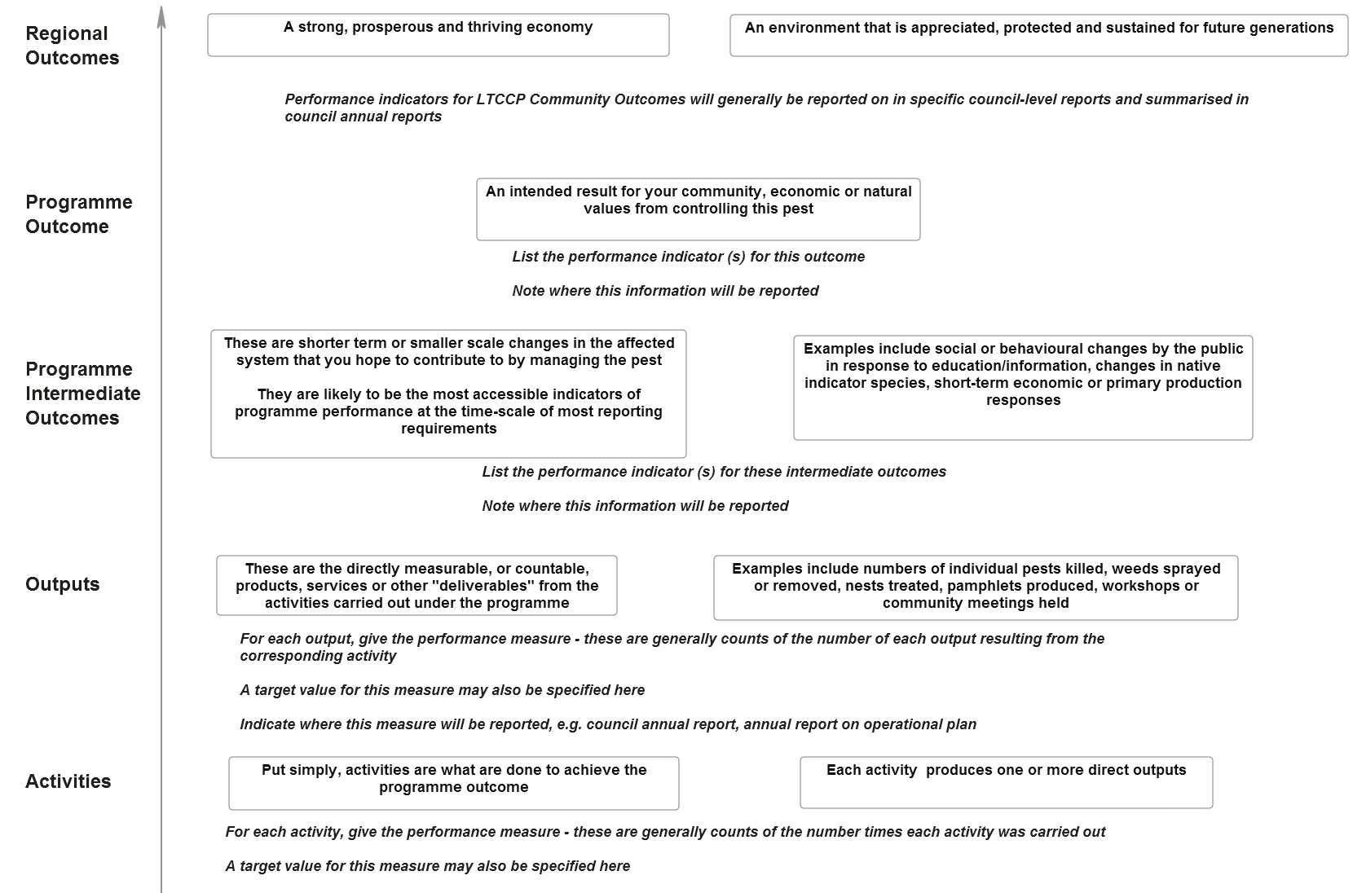
Figure 4 Adding performance measures and reporting links to the intervention logic model.

Evaluation and reporting

Overview
Evaluation of a programme’s performance is particularly important as a basis for improving the programme using new information collected over time. In this section, we describe how the logic model structure can be used in evaluating a programme’s performance and in facilitating clear, targeted reporting.
Evaluation addresses the question of whether a particular management intervention has achieved the desired effect. Evaluation, improvement and other components of managing a programme are part of a linked framework of programme design and management. This framework involves a cyclical or iterative process of management, which relies on information from a monitoring programme and project evaluations to shape further management decisions (The Heinz Center 2009). Figure 5 depicts, as an example, the Australian natural resource management monitoring, evaluation, reporting and improvement (MERI) process.
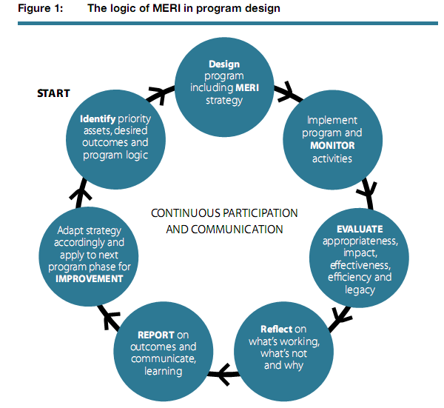
Figure 5 How monitoring, evaluation and reporting fits into a programme management cycle (from Roughley 2009).

A performance cycle, such as Figure 5, should therefore result in improvements in four key areas:
The performance and design of programmes, major strategies and policies
Results flowing from major activities and outputs (including economy and efficiency)
Capability building, particularly in managing for performance
More transparent and representative reporting of major achievements

Evaluation
Within the MERI Framework, evaluation is viewed as a continuous process of participation and communication rather than as a single event. Monitoring, evaluation, reporting and improvement are all activities that contribute to continual learning, which in turn enables improvement in programme design and achievement of desired outcomes.
The MERI guide (Roughley 2009) suggests some key evaluation questions including:
Impact
In what ways and to what extent has the programme or strategy contributed to changing asset condition and management practices and institutions?
What, if any, unanticipated positive or negative changes or other outcomes have resulted as a contribution of the programme?
To what extent were the changes directly or indirectly produced by the programme or project interventions?
Effectiveness
To what extent have the planned activities and outputs been achieved?
Are current activities the best way to maximise impact or are there other strategies that might be more effective?
To what extent is the programme or project attaining, or expected to attain, its objectives efficiently and in a way that is sustainable?
Efficiency
To what extent has the programme or project attained the highest value out of available resources?
How could resources be used more productively and efficiently?
What could be done differently to improve implementation, and thereby maximise impact, at an acceptable and sustainable cost?
Results from each evaluation should be considered relative to the programme’s outcomes and the target values for each measure or indicator. Managers can then identify what is working well and where improvements need to be made. This is a critical process in high-cost pest management programmes where effective evaluation of performance can prevent vital funds being wasted on ineffective interventions.

Reporting
Reports are required to show the degree to which investment or intervention is achieving progress towards targets and outcomes. They also show whether there have been expected or unexpected impacts at different time intervals, and serve to meet accountability requirements. At the regional level, they serve to inform the community of the efforts and resulting progress made towards outcomes on their behalf. The range of reporting requirements for regional pest management programmes are summarised in Table 4.
Reporting performance against outcomes, or more realistically, intermediate outcomes, is currently not common in pest management programmes. As noted in Section 1, there has historically been an emphasis on reporting activities and outputs (e.g. number of site visits; number of pests killed). Unfortunately, this very rarely informs on whether desired changes in community values (biodiversity, social, economic, cultural) have been achieved, despite the necessity for this type of information to convey a picture of an agency’s performance to both ratepayers and executives alike.
Table 4 Potential range of reporting requirements for levels of a logic model for a regional pest management programme
National Outcome from pest management | MAF Biosecurity; Minister
Regional (LTCCP) outcome | Chief Executive, council, community
Programme intermediate outcome | Chief Executive, council, community
Outputs | Managers, council biosecurity committee, community
Activities | Managers, council biosecurity committee, community
Inputs | Managers, council biosecurity committee, accountants
There is a need for clear pest management programme ‘stories’ to be told, in which activities, outputs and outcomes are all reported together. Currently, a common trend is for some details of a programme to be described in one publication, and others to be spread across other reports. To find the details for an individual programme could currently involve reading up to four or five different publications. A typical ‘trail’ may start with an Regional Pest Management Plan and LTCCP, followed by a recent Operational Plan, the corresponding Report on the Operational Plan, the council’s Annual Report and also one or more internal reports to council, where available. Thus, activities, outputs and outcomes are often described in separate documents and measures in yet another.
These apparently conflicting requirements – detail for specific readerships and a ‘big-picture’ overview of the programme that links components – can both be satisfied using logic models that allow performance data at different levels to be utilised according to reporting requirements.

Linking reports to the programme’s logic model
Logic models are a way to summarise a programme and show how all its components link together to lead to the programme’s desired outcome. In this format, and with performance measures linked to programme components, it is instantly clear to a reader how each of those measures relates to the programme as a whole.
A summary spreadsheet or database for internal council use in which indicator values are included for each measurement period will help facilitate reporting of performance at the different levels of the logic model for different readerships. Relevant information can then be extracted from this single source as and when required for reporting. Where this information will be reported, and when, can be included as notes on a programme’s logic model diagram or summary table in key documents such as council plans or Regional Pest Management Strategy.
The cost, time and confidence associated with reporting on each component of a programme’s logic model vary. Shifting from reporting on inputs to outcomes increases the time and cost involved (Silver et al. 2009). This is where it is important to identify a ‘vital few’ key performance indicators for a programme. These will be the measures that indicate performance of key programme components or those chosen by managers to best represent the programme as a whole. It may also be appropriate to use proxy measures that provide evidence that the programme is moving in the expected direction (Section 4.4).

Using performance indicators in an evaluation, reporting and improvement plan
Once outcomes, intermediate outcomes, and performance indicators, metrics and targets have been identified and agreed, a generic evaluation plan should be developed around these key components and should comprise:
Estimates of baseline values for each indicator, so that the degree of change resulting from the programme’s activities can be estimated
Information on data collection and analysis methods
The frequency of reporting (e.g. activity and output reporting will probably occur annually, but intermediate outcome indicators may be reported on at longer intervals)
The form of reporting – how will performance information be used and by whom?
Details on when the programme will next be reviewed and on how performance measurement will be used in programme improvement
Plans for incorporating change in, for example, the assumptions underlying the programme’s logic or in factors that may have a significant effect on the achievement of outcomes

Examples
Figures 6–10 are provided as examples of how graphical logic models can be used to summarise the main components of a programme and to illustrate how these link together. The models, including performance indicators, are based on current pest control programmes run by Hawke’s Bay Regional Council, but were developed for illustrative purposes only and are not intended to represent formal council policy. The models were drawn using the DoView software package (http://www.doview.com/).
Figures 6 and 7 show logic model diagrams for the saffron thistle example developed in Sections 3 and 4 of this guide. Figure 6 illustrates how indicators can be shown in association with the relevant outcomes. Figure 7 shows how arrows can be added to the diagram to make the links between programme components more explicit. There is no right or wrong way of constructing these diagrams. For example, adding the arrows to show linkages can sometimes make a diagram for a complex programme difficult to interpret if there are too many such links. In these circumstances, it may be better to show only the key components of the programme in one model and use more detailed sub-model diagrams to show the links between groups of activities and the outcomes to which they contribute: see Appendix 2 for an example of this.
In the initial scoping and outcome development for a programme, the template in Figure 2 is very useful, but in demonstrating how programme components fit together, it may not be appropriate to display all intermediate outcomes at the same level because some may occupy different places in the logical flow of the programme. Not all intermediate outcomes will be achieved at the same time; sometimes one will contribute to another or may even feed back into a different output: see Figure 9 for an example of this.
The final example in Figure 10 shows how a site-based programme can have its own specific outcome, but can also contribute to wider regional outcomes, for eample for biodiversity, or for a regional species control programme.

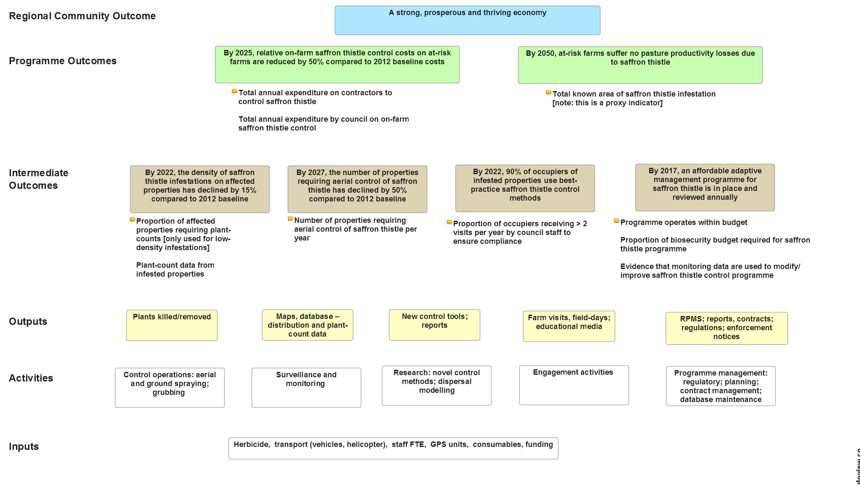

Figure 6 Logic model based on Hawke’s Bay Regional Council’s saffron thistle control programme. Yellow symbols denote outcome performance indicators.
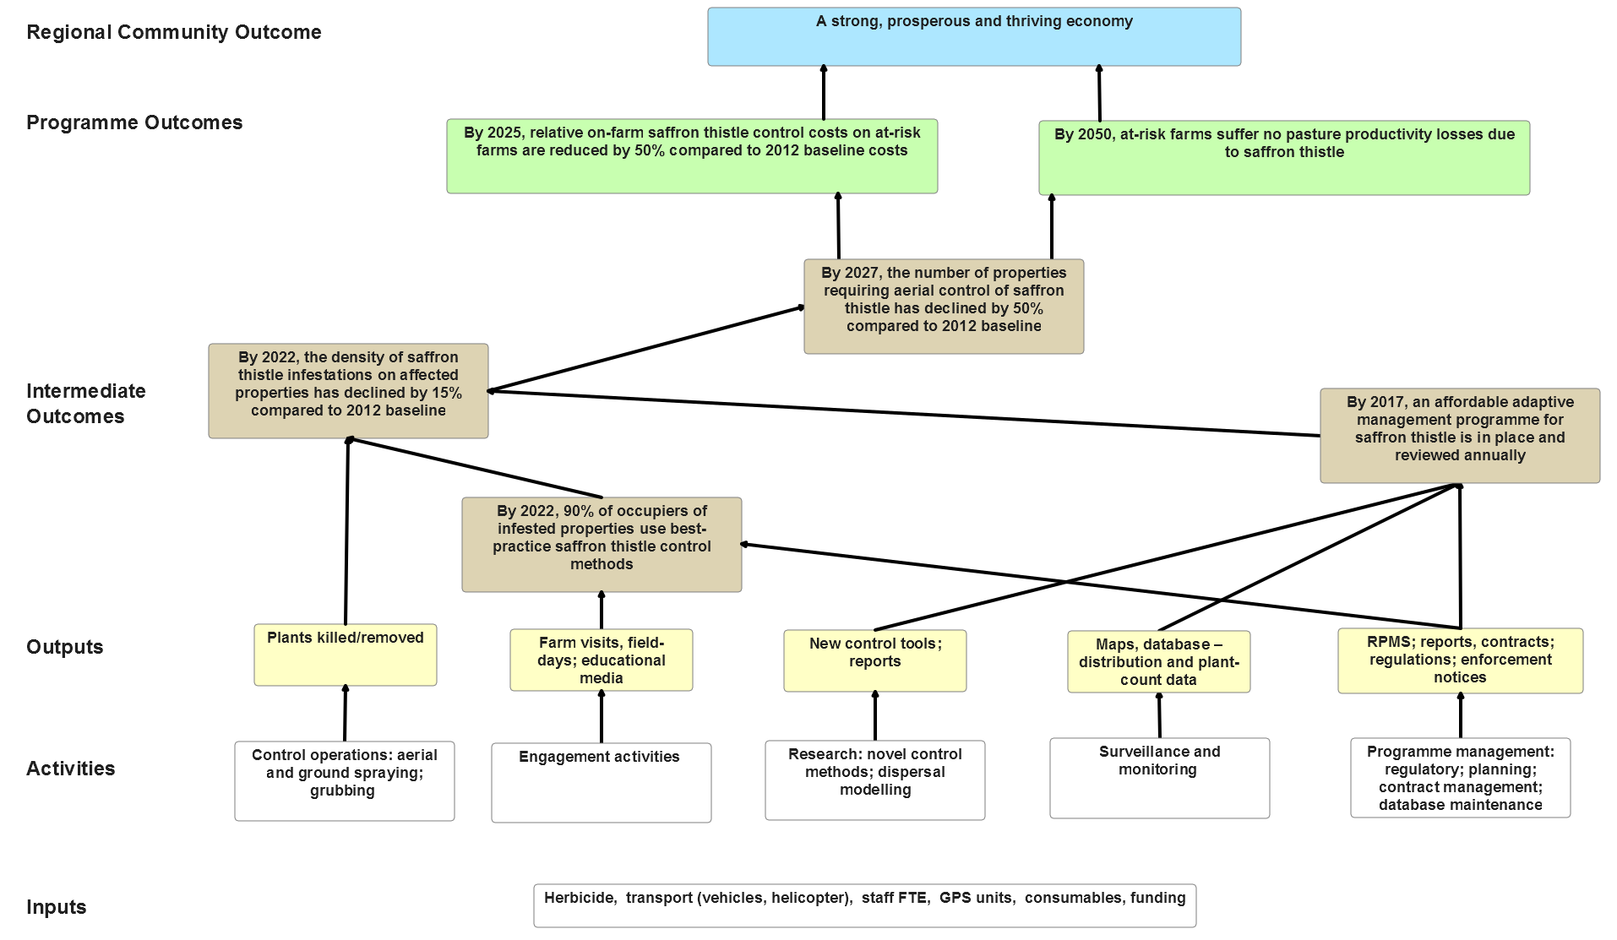
Figure 7 Logic model based on the saffron thistle control programme in Figure 6 showing links between programme components.

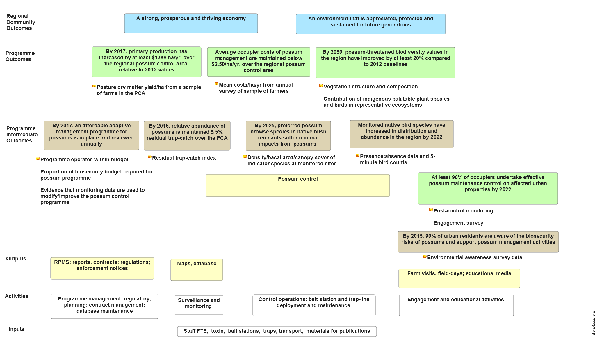
Figure 8 Logic model for a regional possum control programme. Yellow symbols denote outcome performance indicators.
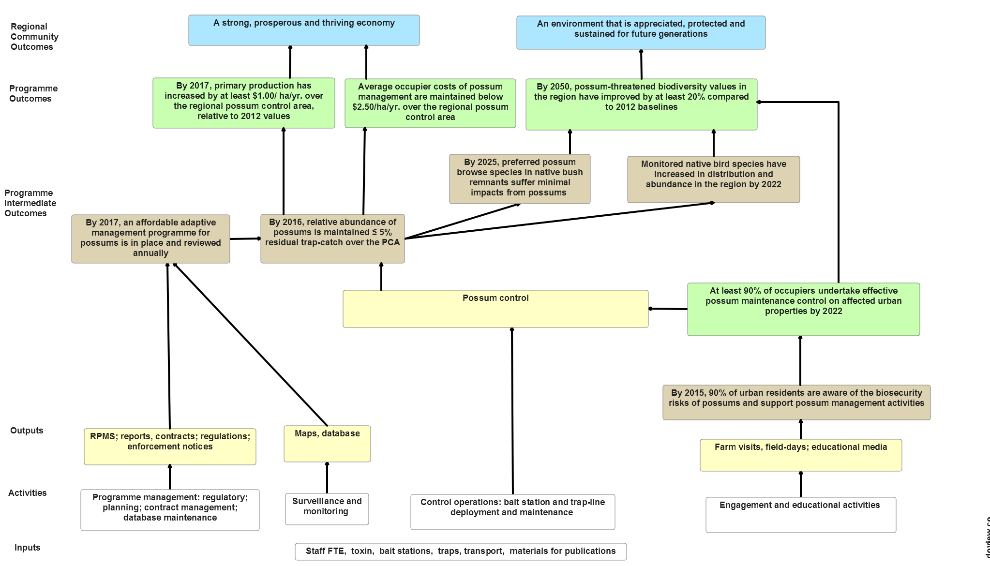Figure 9 Logic model for the regional possum control programme in Figure 8 showing links between programme components.
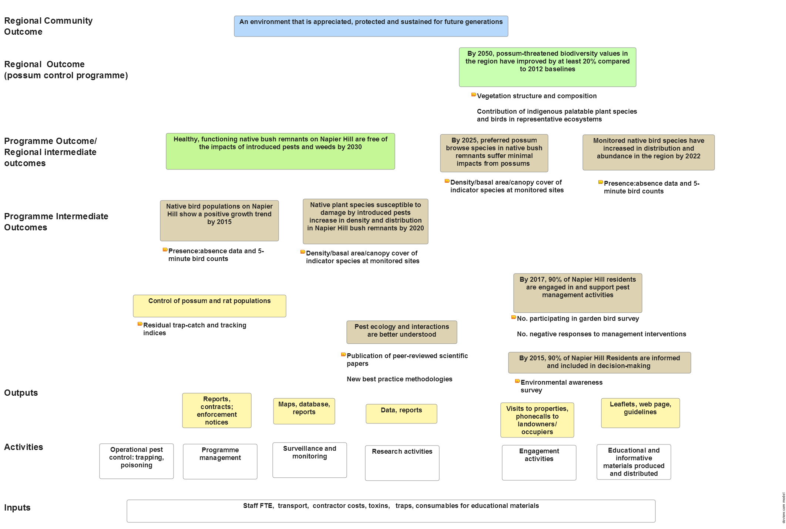
Figure 10 Logic model based on Hawke’s Bay Regional Council’s site-led programme for Napier Hill.

Acknowledgements
Funding for the development of this resource was primarily from Envirolink Tools Grant LCRX1001 supported by co-funding from MAF Biosecurity New Zealand. We are very grateful to the regional council biosecurity managers and their staff who attended our workshop programme and whose comments and feedack on earlier drafts improved this resource greatly. We especially thank Campbell Leckie of Hawke’s Bay Regional Council, who championed this project and alowed us to base our core examples on HBRC pest management programmes. We are also grateful to Christine Bezar for editing and Karen Scott for hosting the web-based version of this guide.

References (cited and additional)
Allen W 2007. Evaluation types and questions. Available online at http://learningforsustainability.net/evaluation/questions.php
Clayton R, Cowan P 2009. Management of animal and plant pests in New Zealand – patterns of control and monitoring by regional agencies. Wildlife Research 37: 360–371.
Cowan PE 2010. Outcome monitoring of pest management. Landcare Research Contract Report LC0910/080 for Hawke’s Bay Regional Council (Envirolink 723-HBRC97).
Green W, Clarkson B 2005. Turning the tide? A review of the first five years of the New Zealand Biodiversity Strategy. Report to MAF-BNZ.
Jones C 2008. Performance measurement in New Zealand pest management: a review of national and international processes and requirements for a national performance measurement framework. Landcare Research Contract Report LC0809/015 for MAF Biosecurity New Zealand.
Jones C 2009. Alignment of council pest management programmes with intervention logic models for performance measurement. Landcare Research Contract Report LC0910/016 for MAF Biosecurity New Zealand.
Lee WG, Allen RB. 2011. Recommended monitoring framework for regional councils assessing biodiversity outcomes in terrestrial ecosystems. Landcare Research Contract Report LC144 for The Regional Council Biodiversity Forum Technical Group
Millar A, Simeone RS, Carnevale JT 2001. Logic models: a systems tool for performance management. Evaluation and Program Planning 24: 73–81.
New Zealand Office of the Auditor General 2008. The Auditor-General’s observations on the quality of performance reporting. NZOAG, June 2008.
New Zealand State Services Commission 2003. Pathfinder. http://io.ssc.govt.nz/pathfinder
New Zealand Treasury and State Services Commission 2008. Performance Measurement: Advice and examples on how to develop effective frameworks (August 2008). ISBN 978-0-478-30345-2.
Roughley A 2009. Developing and using program logic in natural resource management: user guide. Australian Government Land and Coasts Canberra Australia. http://fedpub.ris.environment.gov.au/fedora/objects/mql:2164/methods/c4oc-sDef:Document/getPDF
Note: see also http://www.nrm.gov.au/resources/publications/meri/pubs/meri-framework-march09.pdf
Schacter M 2002. Not a ‘tool kit’. Measuring the performance of public programs. Ottowa, Canada, Institute on Governance. Available at http://www.iog.ca/publications/Guide.pdf.
Silver MJ, Richards R and Cowell S 2009, ‘A guide to designing and implementing performance reporting to increase the confidence of conservation investors’, Bush Heritage Australia, Melbourne.
Stephens T, Brown D, Thornley N 2002. Measuring conservation achievement: concepts and their application over the Twizel area. Science for Conservation 200. Wellington, Department of Conservation.
The Biosecurity Council 2003. Tiakina Aotearoa Protect New Zealand: The Biosecurity Strategy for New Zealand. Wellington. ISBN 0-478-07764-5.
The Heinz Center 2009. Measuring the Results of Wildlife Conservation Activities. Washington, DC, 122 p. http://www.heinzctr.org/Major_Reports_files/Measuring%20the%20Results%20of%20Wildlife%20Conservation%20Activities.pdf
W.K. Kellogg Foundation 2004. Logic model development guide. Available at: http://www.wkkf.org/Pubs/Tools/Evaluation/Pub3669.pdf.
Watson DE, Broemeling A, Reid RJ, Black C 2004. A results-based logic model for primary health care. Vancouver, Canada, Centre for Health Services and Policy Research, The University of British Columbia, Available online http://www.chspr.ubc.ca/files/publications/2004/chspr04-19.pdf

Appendix 1 – Background to the Envirolink Tools project, and national and regional contexts for measuring pest management performance
A1.1 Envirolink Tools Project
Reviews and discussion papers (‘think pieces’) commissioned by the regional councils and MAF Biosecurity NZ (MAFBNZ) concluded that there is significant need to improve:
Definition and monitoring of programme outcomes and the alignment of their associated measurement methodology with best practice
Consistency in the methods and standards used for outcome monitoring and reporting
Consistency in processes and terminology used for defining outcomes across and within agencies
Achieving this requires councils to make more explicit, and demonstrate and communicate more effectively, the links between programmes, their outputs, and the contribution they make to the broader-scale community outcomes being sought under the LTCCPs.
Regional councils and Landcare Research therefore applied to the Envirolink programme (http://www.envirolink.govt.nz/) for funding to address these issues. Part of the project was to produce a training and management resource for applying outcome monitoring processes and tools to the development, reporting and evaluation of council pest management plans and activities. The resource would enable regional councils to use outcome monitoring more effectively to evaluate and report on the services delivered by their plant and animal pest management programmes. It would also guide the selection and development of the measures and indicators required to monitor and report on progress towards outcomes both regionally and against the set of national pest management outcomes set by MAF Biosecurity New Zealand (MAFBNZ).
Key outputs from this Envirolink project were:
Workshops and discussions with key staff from all councils in New Zealand providing tailored training, advice and guidance on best practice for setting, measuring and reporting on outcomes of pest management
A training and management resource for outcome-based performance definition and measurement (in both hard-copy and electronic formats) based on current best practice and input from the individual workshops with councils
A report identifying and prioritising research necessary to support cross-council outcomes-based measures in pest management
A set of agreed common processes to facilitate alignment of council pest management measurement systems and indicators with (a) the national Pest Management Plan of Action and (b) the Department of Conservation’s Natural Heritage Management System (NHMS)

A1.2 National context for pest management performance measurement
Pest management in New Zealand is carried out by a range of national, regional and local agencies to reduce the economic damage due to pests, risks to human health, and the impacts of pests on environmental, primarily biodiversity, values. The New Zealand Biodiversity and Biosecurity strategies both highlight the need for better-coordinated pest management between central and local government agencies.
Individual organisations responsible for managing pests in New Zealand, notably the Department of Conservation (DOC), Animal Health Board (AHB) and regional councils, have acknowledged the need for evidence-based reporting of the benefits of pest management activities to (1) meet obligations under the Resource Management Act amendment (2003) and the Biosecurity Act (1993) and (2) justify and prioritise expenditure on pest management.
In May 2005, the Biosecurity Central Regional Government Forum (BCR) confirmed development of ‘pest management indicators and monitoring for the system as a whole’ as one of its seven strategic priorities for pest management. This strategic priority has been implemented as the Measurement and Review work stream of the wider MAFBNZ-led Pest Management Plan of Action (http://www.biosecurity.govt.nz/pests/surv-mgmt/mgmt/future-project)to develop a performance measurement system for pest management based on best-practice outcomes measurement. This measurement system will link to external agency frameworks based on similar methods that are either currently in use (e.g. AHB) or under development by other national agencies, such as DOC. The system will enable input from regional and district councils to the following:
Monitoring the effectiveness of pest management strategies and approaches across organisations, so that any inconsistencies can be identified and risk and impacts are minimised
Ensuring that learning is captured and communicated among pest management organisations to drive improvement over time
Facilitating reporting and accountability in the pest management sector
A1.3 Regional context for pest management performance measurement
The Local Government Act 2002 obliges territorial authorities to identify, monitor and report on progress towards community outcomes and to describe through their long-term plans how their own activities will contribute to these outcomes. The New Zealand Office of the Auditor General (2008) noted ‘weaknesses’ in LTCCP audits related to: ‘a lack of a logical flow in performance reporting; levels of service, and performance measures and targets; and outcomes monitoring.’ This is particularly so in pest management, where both regional councils (Clayton & Cowan 2009) and MAFBNZ (Jones 2008, 2009) have reviewed the current state of performance measurement and the extent of outcomes measurement and reporting by regional councils. These reviews concluded that there is a significant need to improve:
The definition and monitoring of programme outcomes and the alignment of their associated measurement, methodology and design with best practice
Consistency in methods and standards of outcomes monitoring reporting
Consistency in terminology and processes for defining outcomes across and within agencies
There is a clear need for councils, on ratepayers’ behalf, to make more explicit, and demonstrate and communicate more effectively, the links between programme components, and the contribution those programme’s outputs make to the broader scale community outcomes being sought. The adoption of an outcome-based approach using the framework provided by intervention logic models would allow councils to: ensure programmes are achieving their goals most cost effectively; report performance clearly to internal and external stakeholders; and contribute to and align with the national performance measures for pest management.

Appendix 2 – Logic model for the Didymo Long-term Management Plan

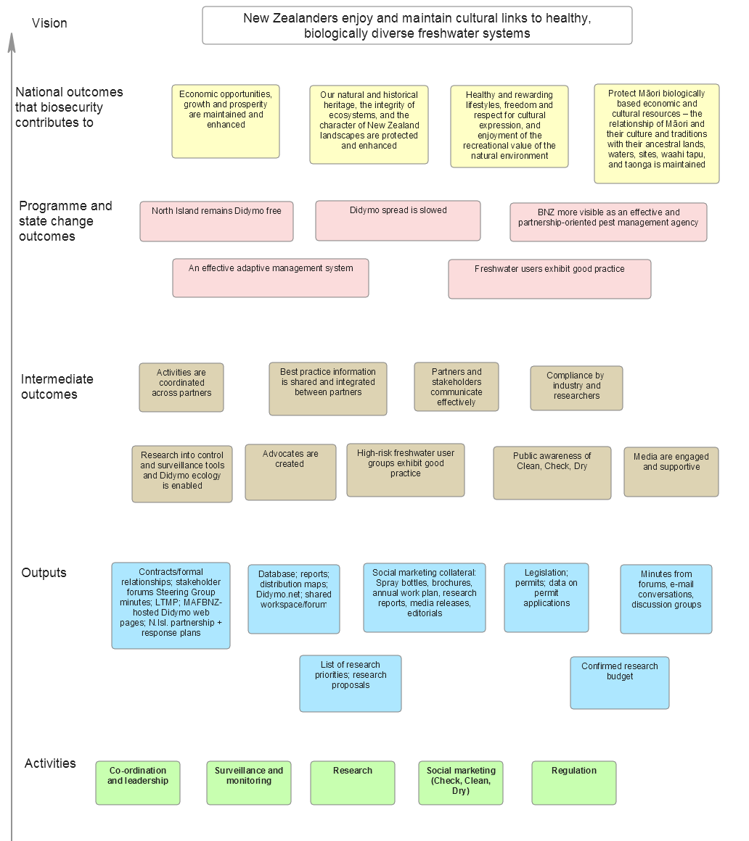
Figure 11 National Didymo Management Programme overview logic model.

Didymo: key assumptions and risks
Overall:
* Eradication or control of didymo not likely in short term.
* It is believed that the role of wildlife in spread of didymo between catchments is low-risk, and that it is most likely spread by human activity. However, there are likely many factors that spread it within catchments.
* Assumed that further contamination could result from just one person not following good practice.
* Expert advice is that didymo was likely to be present outside of the known affected areas.
* Appropriate cleaning methods for river equipment have been developed.
* A partner-based approach is important.
* Greater likelihood of community buy-in through an inclusive rather than regulatory approach.
* Ability for partner organisations to act as channels to disseminate/message/desired behaviour.
Economics
Potential cost to New Zealand ranges between $57 and 285 million.
Ecological
* Any freshwater pest is likely to be able to survive in both South and North Island waterways.
* That Check, Clean, Dry will stop most freshwater pests from spreading.
Behaviour change/Social
We assume that change is a process, and people may move through a number of steps as they move through this process.
Accordingly, programmes will be developed with principles for effective communication (e.g. exchange theory), and they will recognise that they also need to align with social cognitive theory and stages of change model (e.g. Prochaska model, or use some other model).

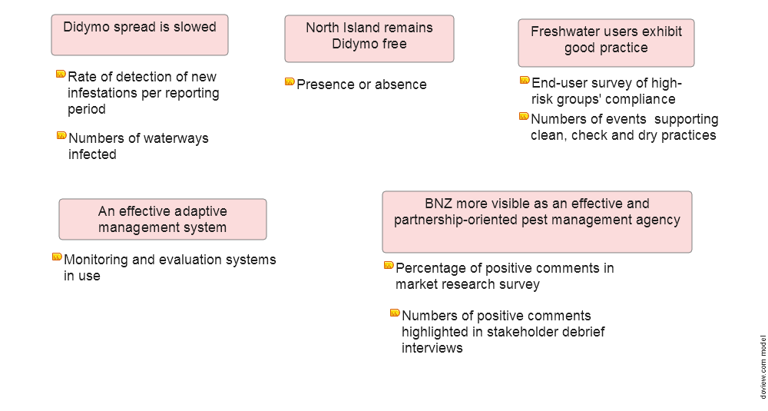
Figure 12 Didymo programme outcomes and performance indicators.

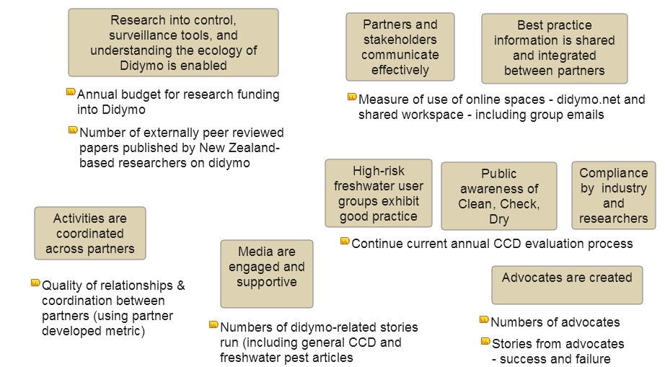
Figure 13 Didymo programme intermediate outcomes and performance indicators. (CCD = Check, Clean, Dry)
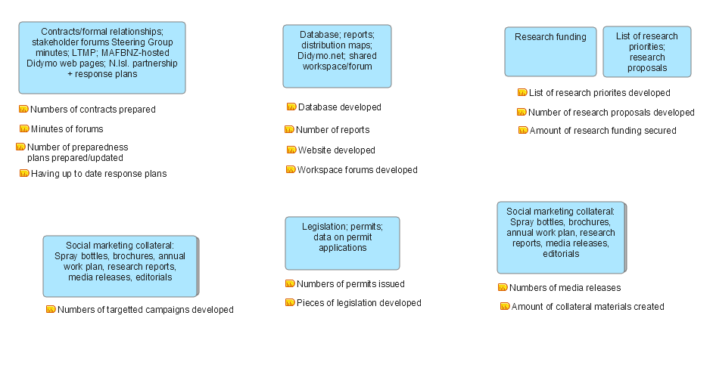
Figure 14 Didymo programme outputs and performance indicators.

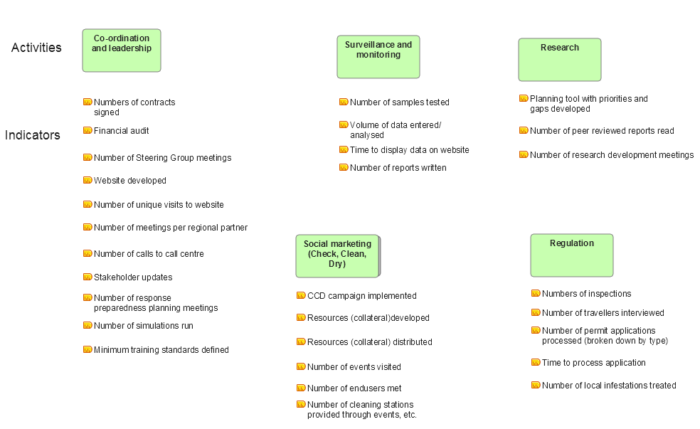
Figure 15 Didymo programme activities and performance indicators. (CCD = Check, Clean, Dry)

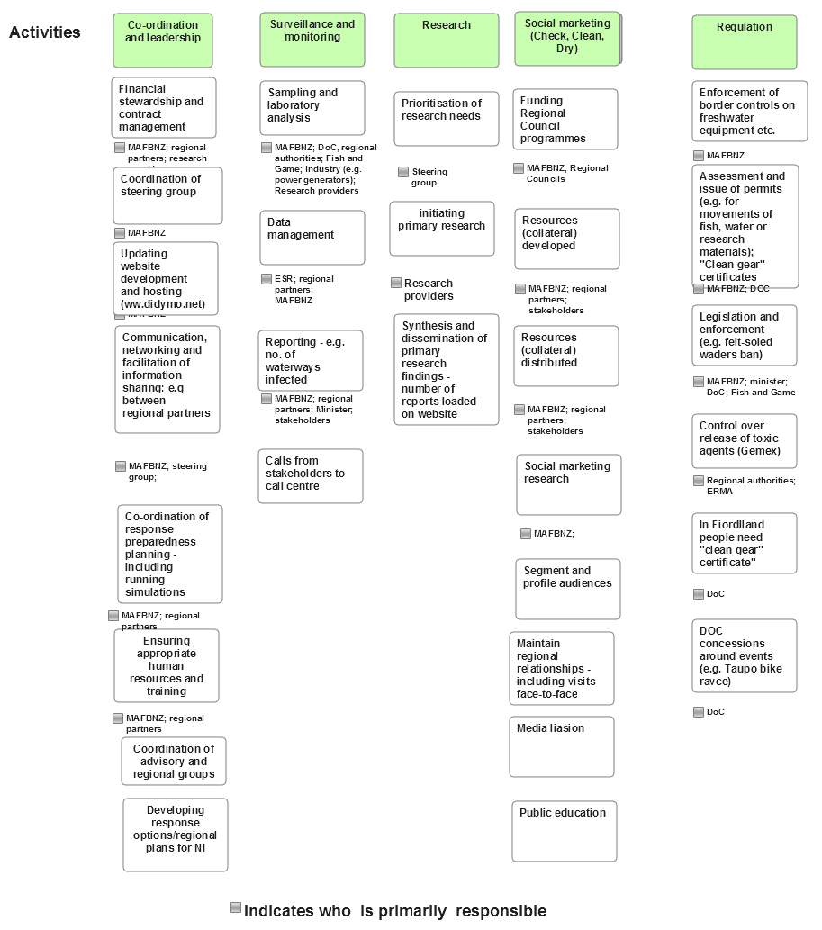
Figure 16 Didymo programme activities and responsibilities.

Appendix 3 – Biodiversity indicators comprising the regional council terrestrial biodiversity monitoring framework
Regional council terrestrial biodiversity monitoring framework
Objective: To provide a national, standardised, biodiversity monitoring programme, focusing on the assessment of biodiversity outcomes, to meet regional council statutory, planning, and operational requirements for sustaining terrestrial indigenous biodiversity
Indicator | Measures | Element | Ecological Integrity | Driving forces-Pressure-State-Impact-Response | Data required and potential sources
State and Condition
1. Land area under indigenous vegetation | Indigenous landcover (ha, %) of cover classes, habitat types, across LENZ and Ecological District units, regions | Spatial depiction of : (i) indigenous cover classes; (ii) habitat/vegetation types; (iii) stratified by LENZ | Environ-mental represent-ation | State | Data: The Land Cover Database is foundational for this indicator, and regular comparable updates are required to detect change over time. This is currently the responsibility of the Ministry for the Environment. Habitat types require a standardised national classification. Some regional councils have their own habitat classifications, and these can change over time. Land Environments of New Zealand (LENZ) and Ecological Regions/Districts are available
2. Biodiversity condition | Vegetation structure and composition | Presence of suitable indigenous component in all structural layers | Species occupancy | State | Data: Requires standardised field sampling, e.g. augmenting LUCAS plots, and agreement of focal species and parameters
 | Avian represent-ation | Presence of suitable bird species across trophic levels | Species occupancy | State | Data: Requires standardised field sampling and classification of birds into relevant guilds
 | Habitat for threatened species | For threatened and at-risk taxa: (i) number, (ii) status of critical habitat | Environ-  mental represent-  ation | State | Data: Formal classification of threatened and at-risk species available. Suitable habitat requirements will require identification
 | Vulnerable ecosystems | (i) Wetlands (condition and extent (ha)); (ii) dunes and other coastal systems (condition and extent); (iii) naturally rare ecosystems (% of area remaining) | Environ-mental represent-ation | State | Data: National classifications available, including national maps for some systems
Threats and Pressures
3. Weeds and animal pests | Number of new naturalis-ations | Number of new regional incursions and/or sites of nationally recognised environmental weed species | Indigenous dominance | Pressure/  Impact | Data: Requires surveillance monitoring at regional level, currently undertaken by regional councils
 | Distribution and abundance | Based on (i) regional distribution and (ii) local abundance of environmental weeds and nationally listed animal pests | Indigenous dominance | Pressure | Data: Operational techniques and data management currently vary across regions. Will require standardisation and development of some new approaches
4. Habitat loss | Change in area under intensive land use | LCDB cover classes within an agreed definition of ‘intensive land use’, e.g. areas actively managed to the general exclusion of terrestrial native biodiversity (i.e. crops, roads, etc.) | Environmental representation | Pressure | Data: LCDB and reruns, while maintaining historical compatibility of cover classes
 | Habitat and vegetation loss | Based on changes in area of land cover classes and naturally rare ecosystems Area of indigenous cover destroyed by fire/aerial spraying over defined period | Environmental representation | Impact | Data: LCDB and reruns, augmented by regional aerial mapping for habitat loss. Standardised data from National Rural Fire Authority, DOC and regional councils
5. Climate change | Change in temperature and precipitation (ppt.) | Based on analysis of mean and extreme (i) annual temperature, (ii) seasonal temperature, (iii) frost frequency, (iv) annual ppt. and (v) seasonal ppt. | Environmental representation | Driving forces | Data: Available from NIWA, augmented by regional council sites
Effectiveness of Policy and Management
6. Biodiversity protection | Change in extent and protection of indigenous cover or habitats or naturally uncommon ecosystems | Based on LCDB repeats and DOC and regional council records and protection layers. Change measured for each cover class/habitat as % remaining/protected and hectares lost/gained | Environmental representation | Response | Data: LCDB and reruns, DOC rare ecosystem maps, and LENZ
 | Vegetation consents compliance | Permit compliance with vegetation clearance rules, especially on scheduled sites | Environmental representation | Response | Data: Regional council compliance inspection data
7. Pest management | Indigenous ecosystems released from pests | Area and land-cover class or habitat where vertebrate densities have low ecological impacts following exclusion fencing or intensive predator control | Indigenous dominance | Response | Data: Regional council, Animal Health Board, DOC data and field measurements at selected sites
 | Change in the abundance of indigenous plants and animals susceptible to introduced herbivores and carnivores | Contribution (richness, basal area, and density) of palatable plant species (e.g. Forsyth et al. 2002) and indigenous birds (herbivores, insectivores, ground dwelling) in representative ecosystems | Indigenous dominance | State | Data: Presence/absence and density data from representative sites, including across variable levels of pest control, from, for example, the National Vegetation Survey Databank
8. Ecosystem services | Extent of indigenous cover in water catchment | (i) Percentage of catchment and (ii) extent of riparian zone under indigenous cover | Environmental representation | State | Data: LCDB and reruns, augmented by aerial photographs of representative areas
Community Engagement
9. Protection and restoration | Area and type of biodiversity protection achieved on private land | New areas (ha) protected through initiatives on private land | N/A | Response | Data: Permanent Forest Sink Initiative, QEII covenants and regional council and DOC reserves / covenant data
 | Contribution of initiatives to (i) species translocations and (ii) habitat restoration | New taxa established and area (ha) and habitat type replanted in region | N/A | Response | Data: Available from community groups (ecosanctuaries), DOC, and some private groups, in addition to regional council data
10. Weed and pest control | Community contribution to weed and animal pest control and reductions | Area (ha) and habitat types with weed and animal pest control by community groups | N/A | Response | Data: Information available from regional council, DOC, and local authorities

Impact is the difference between the system states (e.g. biodiversity or productivity indicator values) before and after your intervention, i.e. the difference that you made.

