Site Name: |  |  |  | Date:
Organisation: |  |  |  | Time of Day:
Observer(s):

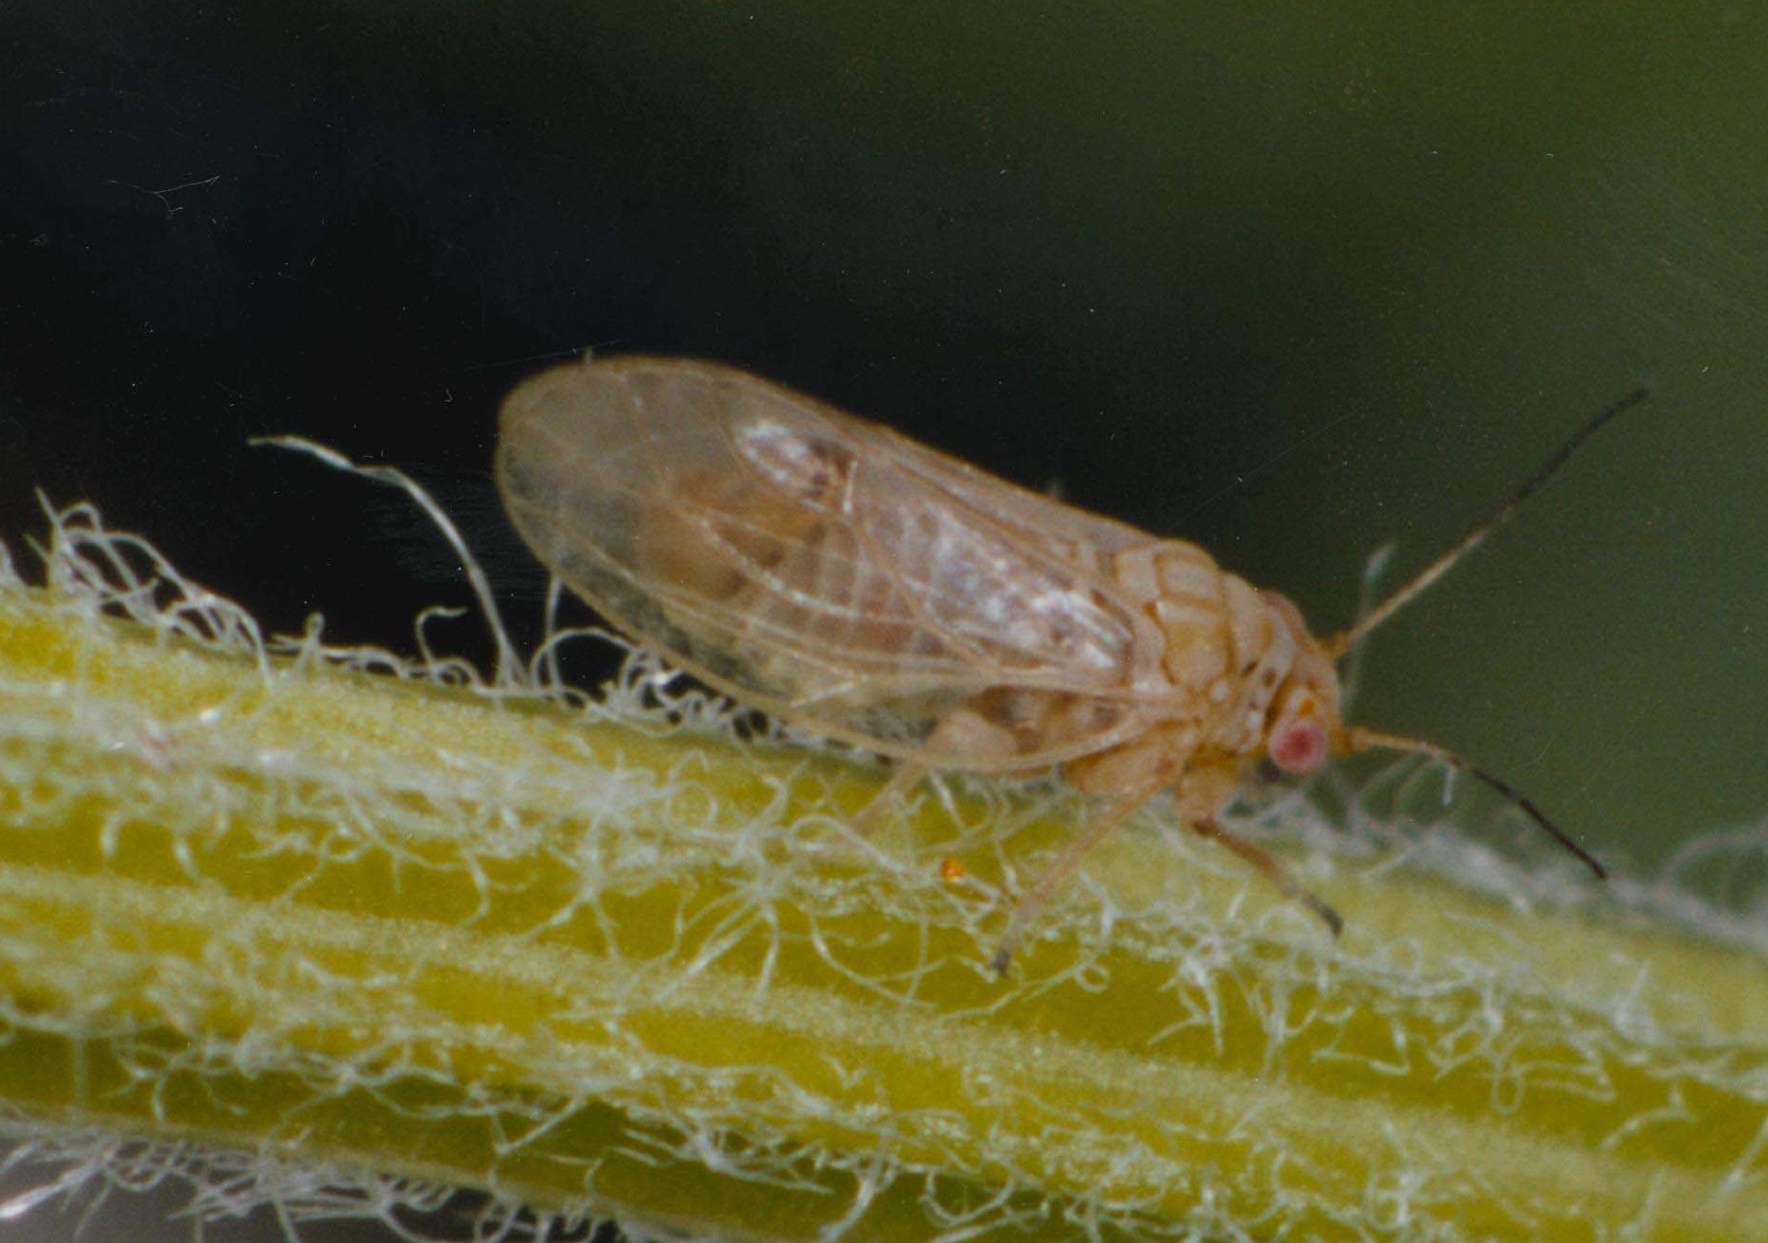
Current Weather Conditions
- Sunny / Partly Cloudy / Overcast / Rain
- Strong Wind / Light Wind / Calm
- Temperature (°C) <10 / 10-15 / 15-20 / 20-25 / >25

Insect Information
4) Number found: Adults: Nymphs:
5) Time spent searching (mins)
7) Furthest distance insect found from release point (m):
None Found / <20 / 20-50 / 50-100 / 100-300 / 300-500 / Further?
8) Overall damage to foliage: None / Occasional / Patchy / Heavy / Severe

Weed Information
9) Most obvious life stage: New Leafy Growth / Flowers / Green Pods / Ripe Pods
10) Broom type at the release point: Isolated Bushes / Clumps / Block
11) Infestation: Major (as far as eye can see) / Moderate (>100m²) / Minor (<100m²)
12) Percentage cover at densest accessible point:
13) Photos taken: Yes / No 14) Photo file name:

Comments
15) Have any of the following happened to the site recently?
Mowing / Spraying / Grazing / Flood / Drought / Fire / Other?
16) Please use the back of this sheet to record any further observations or comments about the site.

BROOM PSYLLID

INSTRUCTIONS FOR FILLING OUT THIS SHEET
(Please note that it is important to complete these questions in order)

Where choices are given mark the correct answer by bolding or highlighting it or by deleting the other options.

- Site Name – please be consistent in the use of site names to prevent confusion.
- Organisation – the name of your organisation.
- Observer(s) – the names of people who helped with this recovery not onlookers.

Current Weather Conditions
1-3) Choose the words that best describe the weather conditions.

Insect information
4) Look for the adults and nymphs from October-November by beating foliage over a 1x1 m white sheet/card/tray. Collect and examine 5 beating tray samples from different bushes with leafy new growth at the release site. For each sample beat a bush or branch briskly twice and examine what is dislodged, before moving to another bush. If no beetles are found spend another 10 minutes beating bushes further away. If you find large numbers it is not necessary to count exactly just estimate how many. If you do not find many collect and examine another 5 samples.
5) Record how long you spent actively searching for them.
6) If you have time to look further afield we would like to know how far away from the release
point you can find psyllids.
7) Record the amount of feeding damage seen overall at the site: occasional (signs of damage present but not common), patchy (signs of damage are present but are variable throughout the site, some plants may have no damage, and others may have heavy damage but this would be rare), heavy (the majority of plants are showing signs of damage and at least some plants are beginning to show signs of severe defoliation/damage or stress), and severe (severe damage is obvious and widespread).
Weed Information
8) Record the most obvious life stage.
9) Record the type of broom growing at the release point.
10) Estimate and record the approximate size of the infestation using the categories provided.
- Estimate the percentage cover of broom at the densest accessible point over an area of 5 x 5m, or if the site doesn’t lend itself to a square use an equivalent sized shape.
- Please indicate if you have taken photos.
- If you have taken photos please record the file name for the photo, and attach hard copies to this form if you can.
Comments
14) Please indicate if any of these important events have happened to the site.
15) Tell us any other important information we should know about the site (e.g. whether you
have been harvesting for release at new sites). Use the top of this page if you need extra space.

