Site Name: |  |  |  | Date:
Organisation: |  |  |  | Time of Day:
Observer(s):
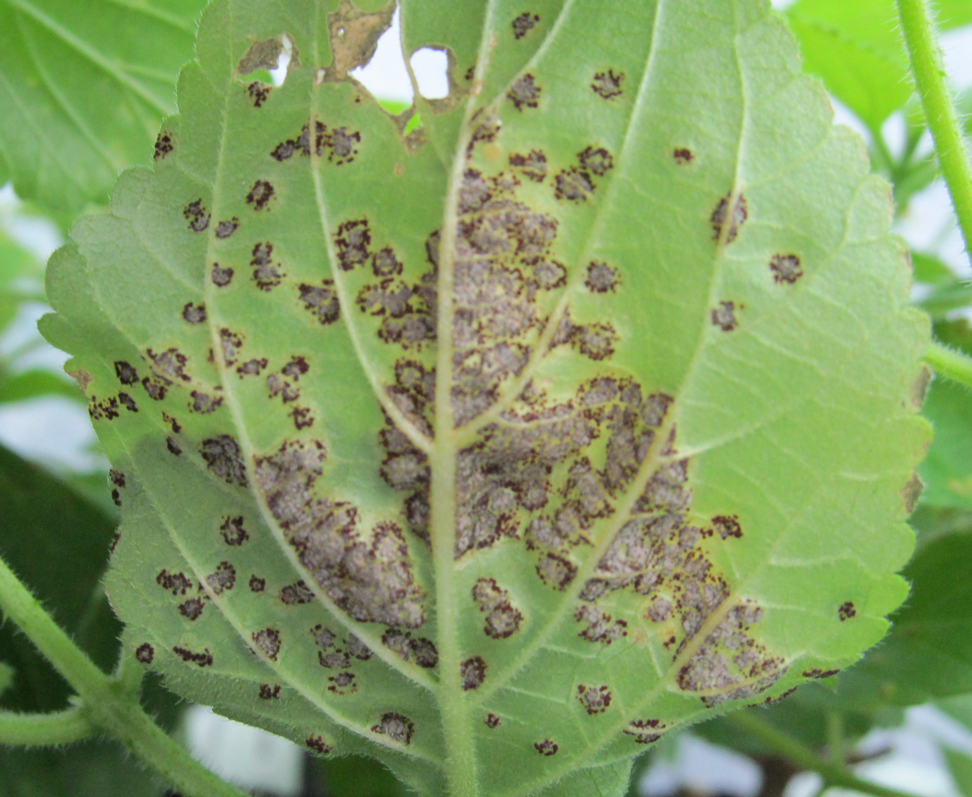
Current Weather Conditions
- Sunny / Partly Cloudy / Overcast / Rain
- Strong Wind / Light Wind / Calm
- Temperature (°C) <10 / 10-15 / 15-20 / 20-25 / >25

Fungus Information
4) Diseased symptoms found: Yes / No
5) Overall damage to foliage: None / Occasional / Patchy / Heavy / Severe
6) Furthest distance symptoms found from release point (m):
None Found / <20 / 20-50 / 50-100 / 100-300 / 300-500 / Further?
7) Time spent searching (mins):

Weed Information
8) Plant type at release point: Isolated plants / Clumps / Solid block
9) Infestation: Major (as far as eye can see) / Moderate (>100m²) / Minor (<100m²)
10) Percentage cover at densest accessible point:
11) Photos taken: Yes / No 12) Photo file name:

Comments
13) Have any of the following happened to the site recently? Yes / No
Mowing / Spraying / Grazing / Flood / Drought / Fire / Other?
14) Please use the rest of the sheet to record any further observations or comments about the site, including any checks for non-target damage. Continue over the page if necessary.

LANTANA BLISTER RUST

INSTRUCTIONS FOR FILLING OUT THIS SHEET
(Please note that it is important to complete these questions in order)

Where choices are given mark the correct answer by bolding or highlighting it or by deleting the other options.

- Site Name – please be consistent in the use of site names to prevent confusion.
- Organisation – the name of your organisation.
- Observer(s) – the names of people who helped with this recovery not onlookers.

Current Weather Conditions
1-3) Choose the words that best describe the weather conditions.

Fungus information
4) Look in spring from October to November or in autumn from March to May for lantana blister rust symptoms. Look for large dark pustules on the stems and underside of the leaves, stunted shoots and die-back of branches.
5) Record the amount of rust damage seen overall at the site: occasional (signs of infection present but not common), patchy (signs of infection are present but are variable throughout the site, some plants may have no signs of infection, and others may be heavily infected but this would be rare), heavy (the majority of plants are showing signs of infection and at least some plants are beginning to show signs of severe defoliation/damage or stress), and severe (severe infection and damage is obvious and widespread).
6) If you have time to look further afield we would like to know how far away from the release point you can find infected plants.
7) Record how long you spent actively searching. Ideally spend 5 minutes checking the release point intensively and then look more widely around the site for another 10 minutes

Weed Information
8) Record the type of lantana growing at the release point.
- Estimate and record the approximate size of the infestation using the categories provided.
- Estimate the percentage cover of lantana at the densest accessible point over an area of 5 x 5m, or if the site doesn’t lend itself to a square use an equivalent sized shape.
- Please indicate if you have taken photos.
- If you have taken photos please record the file name for the photo, and attach hard copies to this form if you can.

Comments
13) Please indicate if any of these important events have happened to the site.
14) Tell us any other important information we should know about the site (e.g. whether you have been harvesting for release at new sites). If you are able to check for non-target damage the species of interest, if they occur nearby, are ornamental verbena e.g. Verbena officinalis, and hybrids. Please indicate if you look and don’t find any non-target damage. If you think you have found some please take photos and specimens to send to us to check. Use the top of this page if you need extra space.

