Site Name: |  |  |  | Date:
Organisation: |  |  |  | Time of Day:
Observer(s):
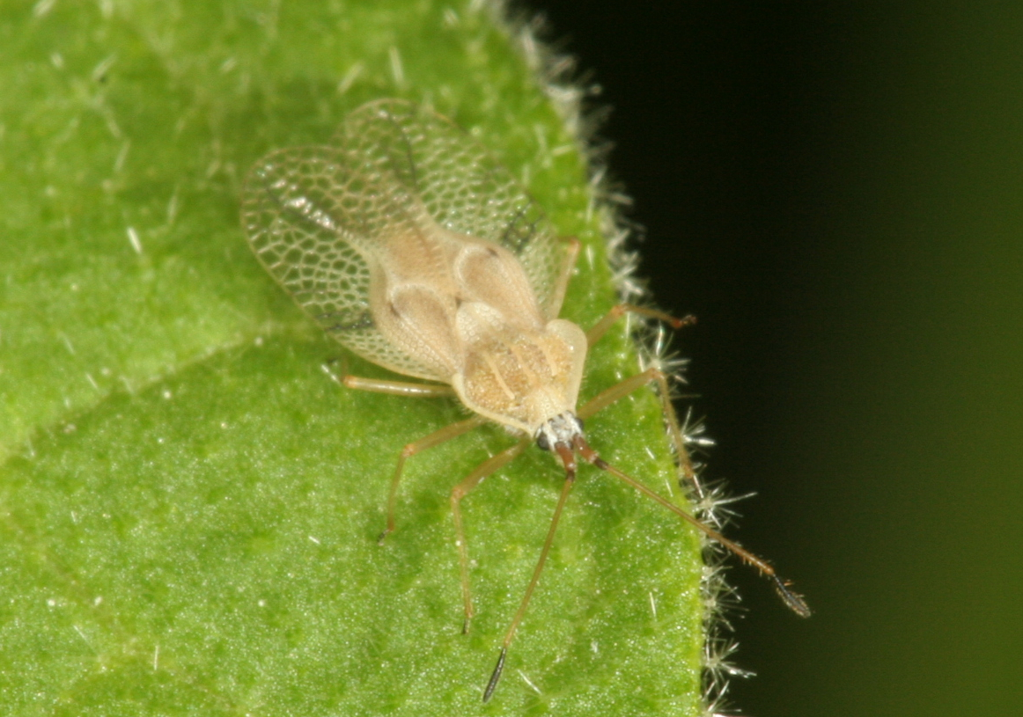

Current Weather Conditions
- Sunny / Partly Cloudy / Overcast / Rain
- Strong Wind / Light Wind / Calm
- Temperature (°C) <10 / 10-15 / 15-20 / 20-25 / >25

Insect Information
4) Number found: Adults Nymphs Egg Batches
5) Overall damage to foliage: None / Occasional / Patchy / Heavy / Severe
6) Time spent searching:
7) Furthest distance insects or damage found from release point (m):
None Found / <20 / 20-50 / 50-100 / 100-300 / 300-500 / Further?

Weed Information
8) Infestation: Major (as far as eye can see) / Moderate (>100m²) / Minor (<100m²)
- Percentage cover at densest accessible point:
- Photos taken: Yes / No 11) Photo file name:

Comments
12) Have any of the following happened to the site recently? Yes / No
Mowing / Spraying / Grazing / Flood / Drought / Fire / Other?
13) Please use the rest of the sheet to record any further observations or comments about the site, including any checks for non-target damage. Continue over the page if necessary.

WOOLLY NIGHTSHADE LACE BUG

INSTRUCTIONS FOR FILLING OUT THIS SHEET
(Please note that it is important to complete these questions in order)

Where choices are given mark the correct answer by bolding or highlighting it or by deleting the other options.

- Site Name – please be consistent in the use of site names to prevent confusion.
- Organisation – the name of your organisation.
- Observer(s) – the names of people who helped with this recovery not onlookers.

Current Weather Conditions
1-3) Choose the words that best describe the weather conditions.

Insect information
4) Look for the pale brown winged adults or the smaller nymphs from February to April. They will often be feeding together in groups and there will be characteristic spots of dark frass around the leaf margins. The darkish eggs are laid in large batches on the undersides of leaves.
5) Damaged leaves looked bleached and fall prematurely. Record the amount of damage seen overall at the site: occasional (signs of damage present but not common), patchy (signs of damage are present but are variable throughout the site, some plants may have no damage, and others may have heavy damage but this would be rare), heavy (the majority of plants are showing signs of damage and at least some plants are beginning to show signs of severe defoliation/damage or stress), and severe (severe damage is obvious and widespread).
6) Record how long you spent actively searching. Ideally spend 5 minutes checking the release point intensively and then look more widely around the site for another 10 minutes.
7) Record how far away from the release point you can find evidence of the lace bug?

Weed Information
8) Estimate and record the approximate size of the infestation using the categories provided.
- Estimate the percentage cover of woolly nightshade at the densest accessible point over an area of 10 x 10m, or if the site doesn’t lend itself to a square use an equivalent sized shape.
- Please indicate if you have taken photos.
- If you have taken photos please record the file name for the photo, and attach hard copies to this form if you can.

Comments
12) Please indicate if any of these important events have happened to the site.
13) Tell us any other important information we should know about the site (e.g. whether you have been harvesting for release at new sites). If you are able to check for non-target damage the species of interest, if they occur nearby, are eggplant (Solanum melongena) and poroporo (S. aviculare, S. laciniatum). Please indicate if you look and don’t find any non-target damage. If you think you have found some please take photos and specimens to send to us to check. Use the top of this page if you need extra space.

