Site Name: |  |  |  | Date:
Organisation: |  |  |  | Time of Day:
Observer(s):
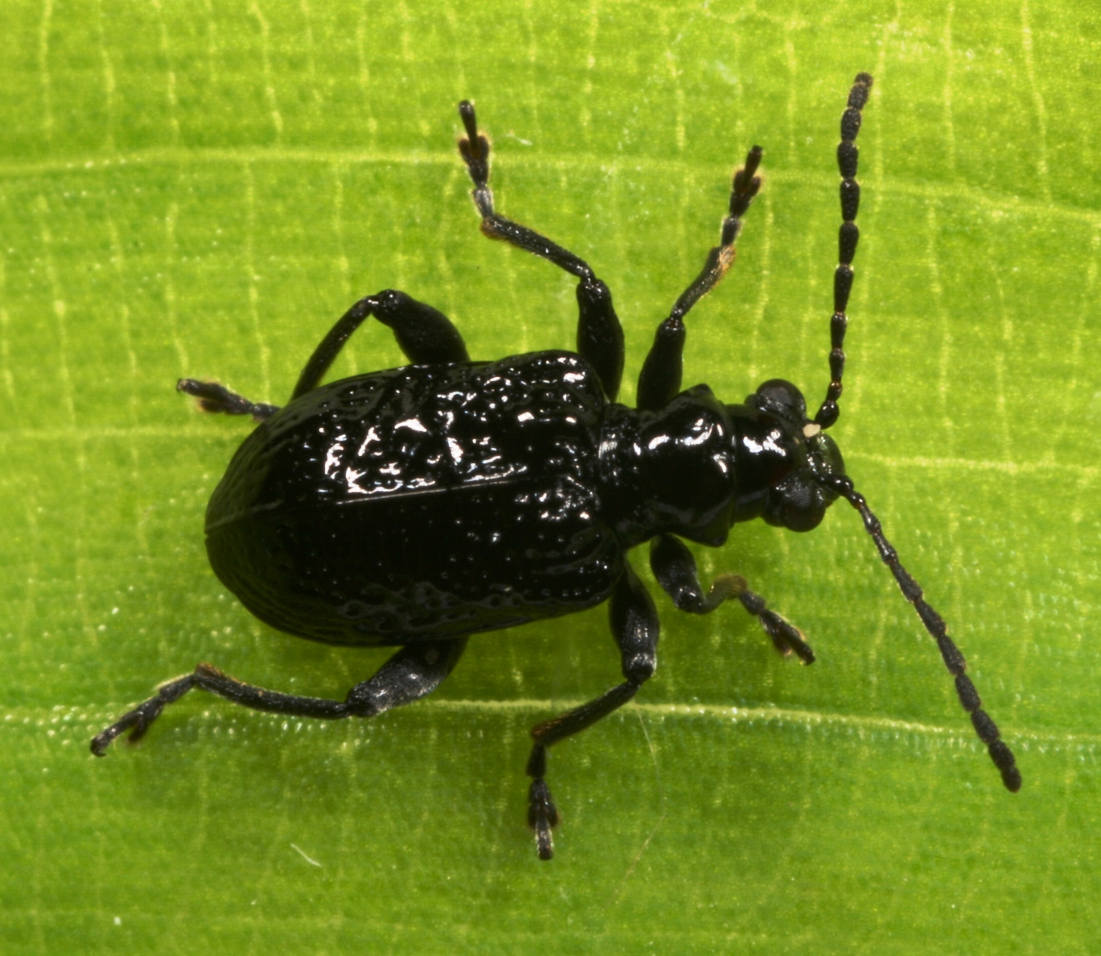
Current Weather Conditions
- Sunny / Partly Cloudy / Overcast / Rain
- Strong Wind / Light Wind / Calm
- Temperature (°C) <10 / 10-15 / 15-20 / 20-25 / >25

Insect Information
- Number of adults:
- Windows in leaves: None / Rare / Common
- Overall damage to stems: None / Occasional / Patchy / Heavy / Severe
7) Time spent searching:
8) Furthest distance insects or damage found from release point (m):
None Found / <20 / 20-50 / 50-100 / 100-300 / 300-500 / Further?

Weed Information
9) Infestation: Major (as far as eye can see) / Moderate (>100m²) / Minor (<100m²)
- Percentage cover at densest accessible point:
- Average height of mat at densest accessible point: <20cm / 20-50cm / >50cm
- Photos taken: Yes / No 13) Photo file name:

Comments
14) Have any of the following happened to the site recently? Yes / No
Mowing / Spraying / Grazing / Flood / Drought / Fire / Other?
15) Please use the rest of the sheet to record any further observations or comments about the site. Continue over the page if necessary.

TRADESCANTIA STEM BEETLE

INSTRUCTIONS FOR FILLING OUT THIS SHEET
(Please note that it is important to complete these questions in order)

Where choices are given mark the correct answer by bolding or highlighting it or by deleting the other options.

- Site Name – please be consistent in the use of site names to prevent confusion.
- Organisation – the name of your organisation.
- Observer(s) – the names of people who helped with this recovery not onlookers.

Current Weather Conditions
1-3) Choose the words that best describe the weather conditions.

Insect information
4) Look for the shiny black 4-5mm long adults from November to April. They have a distinctive knobbly appearance when viewed up close, and may fall to the ground when disturbed.
5) Record the prevalence of elongated windows in the upper surfaces of leaves, caused by adults feeding: none, rare (occasional leaf with windows), or common (easy to find).
6) Record the amount of damage to stems seen overall at the site: occasional (signs of damage present but not common), patchy (signs of damage are present but are variable throughout the site, some plants may have no damage, and others may have heavy damage but this would be rare), heavy (the majority of plants are showing signs of damage and at least some plants are beginning to show signs of severe defoliation/damage or stress), and severe (damage is obvious and widespread).
7) Record how long you spent actively searching. Ideally spend 5 minutes checking the release point intensively and then look more widely around the site for another 10 minutes.
8) Record how far away from the release point you can find beetles or damage.

Weed Information
- Estimate and record the approximate size of the infestation using the categories provided.
- Estimate the percentage cover of tradescantia at the densest accessible point over an area of 5 x 5m, or if the site doesn’t lend itself to a square use an equivalent sized shape.
- Measure the average height of the tradescantia mat at the densest accessible point and select appropriate option.
- Please indicate if you have taken photos.
- If you have taken photos please record the file name for the photo, and attach hard copies to this form if you can.

Comments
14) Please indicate if any of these important events have happened to the site.
15) Tell us any other important information we should know about the site (e.g. whether you have been harvesting for release at new sites). Use the top of this page if you need extra space.

